INSTRUCTION PAMPHLET

No, 5026
AUGUST-1943
Reprinted November, 1952
CROSS COMPOUND

STEAM DRIVEN AIR

COMPRESSORS

WESTINGHOUSE AIR BRAKE COMPANY
AIR BRAKE DIVISION WILMERDING,PA., U. S. A.

CROSS COMPOUND STEAM DRIVEN

AIR COMPRESSORS
INSTRUCTION PAMPHLET

No. 5026
AUGUST ' 1943
Superseding lssue of February, 1912)
Copyright, 1943. by the
WESTINGHOUSE AIR BRAKE COMPANY
AIR BRAKE DIVISION WILMERDING, PA., U. S. A.

CONTENTS
TITLE PAGE
Cross Compound Air Compressors 5
8 1/2" Cross Compound Air Compressor. 7
Description 9
Old and New Standard Air Compressors 15
10 1/2" Cross Compound Air Compressor 17
Operation of Cross Compound Air Compressors.... 18
Type "G" Air Filter 25
No. 54 Air Strainer 26
General Data 30
Installation and Operating Instructions 33
Type "F-1-A" Lubricator 43
Repair Shop and Road Tests 55
Test of Steam End 59
Disorders 62
Maintenance 65
Cleaning the Type "G" Air Filter 70
3

Fig. 1. Front View of the 8 1/2" Gross Compound Air Compressor with "F-1-A" Lubricator, Type "A" Air Inlet Manifold and Type "G" Air Filter
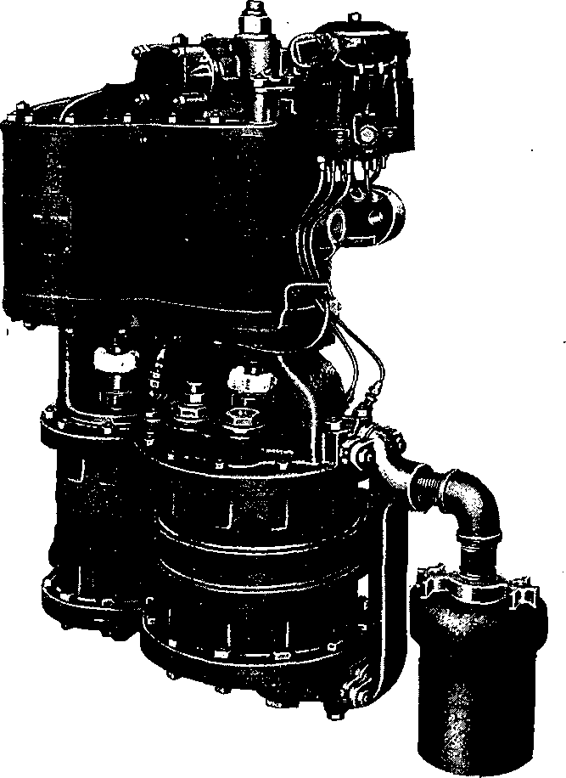

Cross Compound Air Compressors
NOTE—The reference numbers shown herein are for convenience only and are not to be used when ordering repair parts. See Part Catalog giving piece numbers, etc.
It is generally recognized that the duty imposed upon the locomotive air compressor has very largely increased from year to year, but the extent of this increase is more fully appreciated when the following factors are considered:—
- The development of locomotives of great weight and tractive power and in consequence longer trains of heavy, large capacity cars.
- The large brake cylinders and reservoirs required for the heavier cars, the longer brake pipe due to the longer trains hauled, and the greater num-
ber of flexible connections and fittings where leakage may occur, combine to demand normally a larger volume of compressed air than ever before.
- The growing use of many pneumatically operated auxiliary appliances, such as water scoops, automatic ash pans, engine reversing appliances, Pullman water raising system, bell ringers, etc., which take their supply from the air compressor.
- The necessity of avoiding delays at terminals where traffic tends to congest, by a prompt charging of long trains. Present day service conditions demand a compressor of ample capacity to. secure maximum brake efficiency.

Fig. 2. Rear View of the 8Cross Compound Air Compressor with "F-1-A" Lubricator
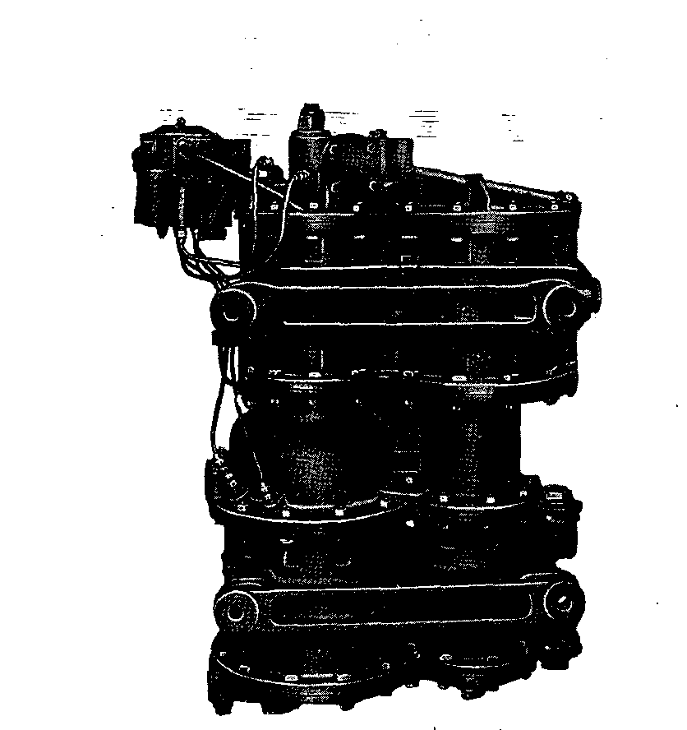

8 1/2"
The Westinghouse 8 1/2" Cross Compound Compressor was developed for the specific purpose of combining maximum capacity and highest efficiency., by compounding both the steam supplied and the air compressed to the extent that, while this compressor has a capacity over three times greater than the well known 9 1/2 " single stage compressor, the steam consumption per 100 cubic feet of air compressed is but one-third. -
The 8 1/2" compressor is supplied in twosizes. The 8 1/2"—150, ordinarily used in steam road service, has a normal displacement of 150 cubic feet when operating on 200 pounds steam pressure. The —120 was designed to operate on a lower steam pressure, and has a normal displacement of 120 cubic feet when operating on 160 pounds steam pressure.
While the cross compound air compressor was originally designed to operate on saturated steam at a maximum of 200 pounds pressure, the introduction of superheat steam and higher pressures was later responsible for modifications providing operation on steam pressures up to 275 pounds.
The present recommended standard 8 1/2"—150-D air compressor is suitable for use with both saturated and superheat steam up to 300 pounds pressure.
A Special air compressor, known as the 8 1/2—150-S, is available for steam 7 pressures up to 400 pounds pressure.

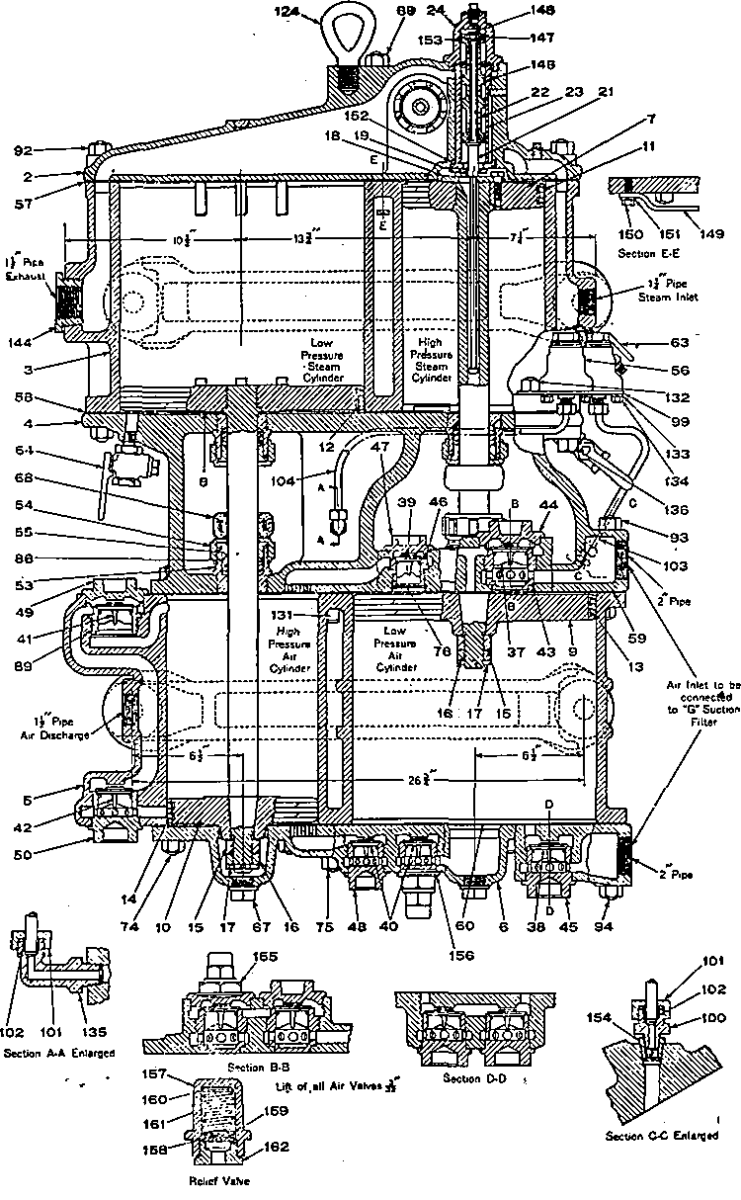
Fig. 3.
*
Sectional View of Compressor Showing the Standard Piston Type Reversing Valve
Present

Description
The steam cylinders are placed vertically above the air cylinders and connected by a common center piece, see exterior views, Figs. l_and 2.
The sectional assembly view, Fig. 3, serves to illustrate the simplicity of this design and emphasize the fact that the cross compound compressor is a serial arrangement of two standard single stage compressors, actuated by the same controlling mechanism, and with pistons moving uniformly in opposite directions. This illustration also shows the few moving parts, employed, which comprise (a), the high pressure steam and low pressure air pistons, connected by a Nickel-Chrome steel piston rod drilled for the reversing valve rod which operates the reversing valve, and which in turn actuates the main piston valve controlling the admission of steam to and the exhaust from both the high and low pressure steam cylinders; and (6), the low pressure steam and high pressure air pistons connected by a solid Nickel- Chrome steel piston rod having no mechanical connection with the valve gear.
The drain cock 63 is intended to draw off any condensation in the steam passage and should always be opened when the compressor is first started The drain cocks 64, connected to both steam cylinders, are for the same purpose and should also be opened for a short time before the compressor is started so that any condensation of steam in the cylinder may be removed.

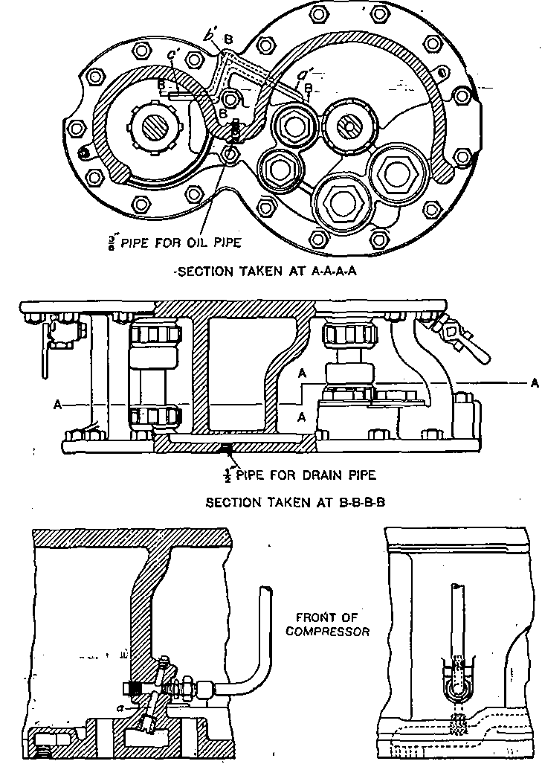
Fig. 4. Views of Center Piece, Showing Drainage and Location of Oil Hole for High Pressure Air Cylinder

Fig. 4 shows partial sectional views of the center piece of the compressor, illustrating the provision made for draining off from the center piece the water which drips from the stuffing boxes. The water which thus accumulates is drained through passages a' and c' to b' and thence through the drain pipe connection on the lower flange to some convenient point, as between the engine frame.
Fig. 4 also shows the present location of oil hole for the high pressure air cylinder. Whereas the oil hole was formerly located near the discharge passage from the high pressure cylinder, an oil hole is now located at a point where the oil will feed directly into the inlet passages to the high pressure air cylinder. The center piece is tapped for 3/8-inch pipe on both the front and back of the rear wall, thus permitting of attaching the oil pipe at either the front or the back. Our standard practice, however, is to connect the oil pipe at the front for the. sake of accessibility, with the back opening plugged. Interchangeability is not affected in any way since the old connection is still retained.
The arrangement of holes, as illustrated, enables the oil passage in the center piece to be cleaned out merely by removing the plug at the top of the angular hole a and introducing into it a straight inflexible rod.
Plates 1 and 2, are diagrammatic views in which the piston valve and reversing valve are turned 90 degrees horizontally from their actual position in order to make the operation more easily understood and all ports and passages are connected in the simplest-possible manner, without regard to the actual construction of the compressor.

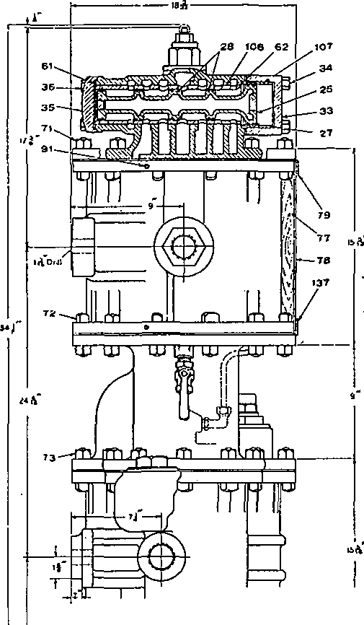
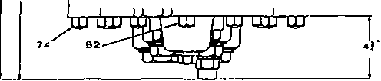

Outline of Compressor with Sectional Assembly Views of the Standard Design Main Valve and Housing

Referring to Plate 1, steam inlet passage a, communicating with cavity K and the two chambers A and A', conveys the steam from the source of supply to the operating valves, of which there are two, namely: the reversing valve 22, and the piston valve 25. The piston valve is a multiple piston device, consisting of a large piston at one end, with four smaller intermediate pistons of uniform size, which will be referred to hereinafter as numbers 1, 2, 3, and 4, numbering from the small piston end of the piston valve.
It is evident, that with five pistons working in a cylinder, we have, including the ends, six separate chambers. In this particular construction, five of these chambers have permanent connections as follows:
The first chamber, E, behind the outer end of the first small piston, to the atmosphere.
The second chamber A, between the first and second pistons, to passage a.
The third chamber F, between the No. 2 and No. 3 intermediate pistons, to the lower end of the low pressure steam cylinder (passage f).
The fourth chamber D, between the No. 3 and No. 4 intermediate pistons, to the upper end of the low pressure steam cylinder (passage d).
The fifth chamber A' between the fourth intermediate and the inner side of large piston, to steam inlet passage a.
The reversing valve 22 moving vertically, controls the admission and exhaust of steam from cavity N, behind the outer end of the large piston of the piston valve, causing it to operate horizontally, the intermediate pistons moving as follows:

Intermediate piston No. 4 crosses a port connecting with passage c, controlling the flow of steam to the upper end of the high pressure steam cylinder, and also the exhaust into the upper end of the low pressure steam cylinder.
Intermediate piston No. 3 crosses a port connecting with passage e, controlling the exhaust of steam from either end of the low pressure steam cylinder.
Intermediate piston No. 2 crosses a port connecting with passage g, causing steam to be admitted to the lower end of the high pressure steam cylinder or exhausting steam from this cylinder into the lower end of the low pressure steam cylinder.
The recent addition of four grooves to the inner end of the large main valve bushing 107 (Fig. 5) serves to prevent possibility of vibration of the main valve when the compressor is operating under a very restricted throttle. Under this condition should the reversing valve fail to supply and maintain steam pressure on the outer face of the large piston equal to that on the inner side, these by-pass grooves serve to equalize the pressure on the large piston before the by-pass grooves in the small piston cylinder balance the pressures at that end. The large piston is thus brought into full balance regardless of the condition of the reversing valve and related parts, thereby preventing rebound of the main valve and resultant vibration.
The piston type reversing valve is a multiple piston device (similar to the main valve) consisting of four pistons of the ,same size except the upper piston which is slightly smaller (see Fig. 3). A port z through the piston valve equalizes the pressures at each end and the

difference in size of the end pistons is such as to compensate for the weight of the reversing valve and rod so that these parts are always in balance.
Chamber B between the two upper pistons is always in communication with the exhaust port e. Chamber K, between the two lower pistons is at all times connected to the steam inlet passage a. The reversing valve cap serves as a bush for the upper piston and permits removal of the reversing valve.
Relief valves 155 (section B-B) and 156, Fig. 3, which are constructed as shown by the small section at the foot of Fig. 3, are for the purpose of preventing excessive pressure development in the low pressure air cylinder, due to leakage past the high pressure or intermediate discharge valves which might otherwise interfere with normal operation of the compressor.
Old and New Standard Air Compressors
The preceding description applies to the two new standard 8 1/2 compressors which are intended for use with steam pressures up to 300 and up to 400 pounds as already stated. The principal difference between the present standard and the former standard compressor (for steam pressures up to 275 pounds) is that the new compressors employ materials suitable for the higher steam pressures and temperatures, and new type top heads. A piston type reversing valve performs the same function as the slide valve type but is subject to less friction, resulting in less strain on the reversing valve rod and insuring better performance. The main valve in the new top head is of one piece construction and the small end piston is the same size as the intermediate

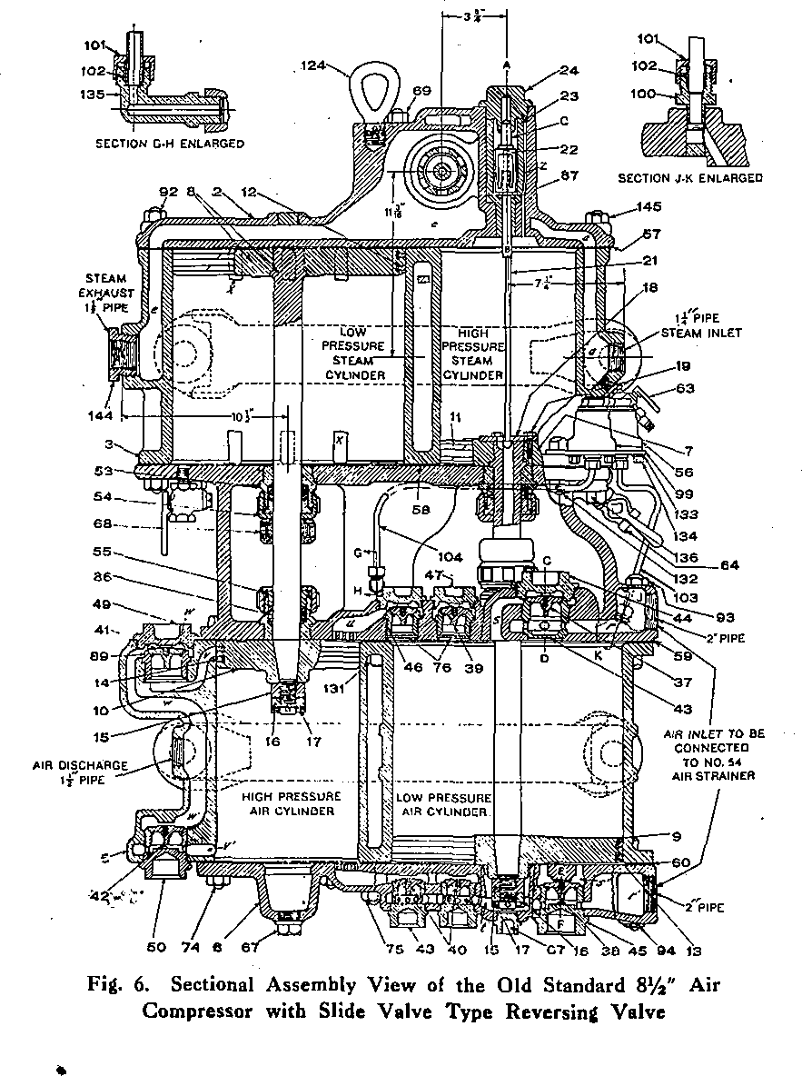

pistons. The use of a bushed cover for the large piston end, and a flat cover for the small piston end makes it possible to apply the main valve without danger of breaking the rings since all rings can be observed.
The diagrammatic views, Plates 1 and 2, represent the new standard compressors but the slide valve reversing valve is shown by small supplementary views, and the section of this pamphlet under "Operation" applies equally to both the old and the new standard compressors.

10 1/2" GROSS COMPOUND AIR COMPRESSOR
The use of compressed air in the industrial field has been so widely extended that the 10 1/2cross compound compressor was developed for this particular service, where ordinarily, steam is not available at the high pressure used in railway braking service, and the air pressures used are not so high.
The 10 1/2" compressor operates on the relatively low steam pressure of 100 pounds, with a normal displacement of 150 cubic feet of air at 80 pounds pressure. The air cylinders are not water jacketed and no intercooler is required. In all essential details this compressor follows the same general design as that of the 8 1/2" compressor' previously described.
General data covering the principal dimensions,, weight, etc., of the 10 1/2" compressor is given on page 32.
General Instructions for the installation and care of 10 1/2" compressors in industrial service are covered by Descriptive Leaflet No. 2341.

OPERATION of C. G. Air Compressors
See, Diagrammatic Views, Plates 1 and 2
When the high pressure steam piston 7 has nearly completed its up stroke, the reversing valve plate 18 comes in contact with the shoulder on the reversing rod 21, forcing this rod to its uppermost position, carrying with it reversing valve 22, the movement of which, in turn, not only blanks passage m, thereby cutting off means of exhausting steam from chamber N on the face of the large piston, but also opens passage n, filling this chamber with live steam from steam inlet passage a. The pressure thus exerted on the face of the large piston added to the pressure on the inner side of the small piston 1, is now greater than the pressure exerted against the inner side of the large piston, and the main valve
moves toward the left, or in the direction of chamber E.

The small end piston cylinder bush is provided with elongated grooves. These grooves have been considered for the sake of simplicity as combined into one groove, p. As the piston valve moves toward the left and uncovers these grooves, live steam from chamber A by-passes to chamber .E back of the small end piston. At the instant these grooves are cut off by the further movement of the piston, port o leading to the exhaust is also blanked which enables the small piston to compress the steam in chamber E, thus providing a high cushioning pressure. This movement of the main valve admits steam, through passage c, to the upper end of the high pressure steam cylinder, starting the high pressure steam piston on its

operation
19
downward stroke. All parts have now assumed the position shown in Plate 1.
A direct communication is now established whereby live steam is supplied through passage a, chamber A', and passage c to the upper end of the high pressure steam cylinder, forcing downward the high pressure steam piston 7 and low pressure air piston 9, which are rigidly connected by a piston rod. The movement of the piston valve to the left, as described above, has opened passage g to passage / through chamber F, thus permitting the steam in the lower end of the high pressure steam cylinder to expand into the lower end of the low pressure steam cylinder under piston 8. The latter cylinder being of materially larger volume than the former, it will be seen that the steam is thereby made to do its work expansively in the low pressure steam cylinder. At the same time—
- the low pressure air piston 9 is compressing air in the lower end of the low pressure air cylinder and forcing same through the intermediate valves 40 and passage u' into the lower end of the high pressure air cylinder under piston 10, and—
- air at atmospheric pressure is being drawn into the upper end ,of the low pressure cylinder, through the air strainer, upper inlet opening, and past inlet valve 37.
It will be observed that the steam exhausted into the lower end of the low pressure steam cylinder and the low pressure air forced into the lower end of the high pressure air cylinder act simultaneously on the lower sides of their respective pistons. The force thus exerted results in an upward movement of the low pressure steam

and high pressure air pistons. The upward movement causes the high pressure air piston 10 to compress the air in the upper end of the high pressure air cylinder to its final pressure, and to discharge it through passage u, past discharge valve 41, and through passage w into the main reservoir. Steam is exhausted from the upper end of the low pressure steam cylinder through passage d, chamber D and passage e to the atmosphere.
After the low pressure steam piston 8 has completed its upward stroke, as explained, the lower end of the high pressure air cylinder, is of course, filled with air compressed from the lower end of the low pressure air cylinder, and the lower end of the low pressure steam cylinder is filled with steam exhausted from the lower end of the high pressure steam cylinder. However, just as the low pressure steam piston 8 has completed its upward stroke, steam is by-passed through three by-pass grooves x from the lower to the upper side of this piston, thereby preventing an accumulation of back pressure in the lower end of the high pressure steam cylinder.
At this stage of the cycle, also, the upper end of the low pressure air cylinder is filled with air at atmospheric pressure and the upper end of the high pressure steam cylinder is filled with live steam; but just before the high pressure steam piston 7 completes its downward stroke, reversing valve plate 18 engages the button end of the reversing valve rod, moving it downward and carrying the reversing valve to its extreme lower position, thereby closing passage n, cutting off the supply of live steam to chamber N, and connecting passage m, cavity B and passage b, thereby exhausting steam from chamber N on the face of the large main valve piston. Since the

pressure against the inner side of the large piston is now greater than the pressure exerted against the inner side of the small piston 1, the piston valve moves to the right or in the direction of chamber N, and all parts are in the position shown in Plate 2. -
Live steam is now supplied from passage a, through chamber A, and passage g, to the lower end of the high pressure steam cylinder, forcing upward the high pressure steam piston 7 which, as already explained, carries with it the low pressure air piston 9. At this time also, steam is exhausted from the upper end of the high pressure steam cylinder, through passage c, chamber D and passage d, into the upper end of the low pressure steam cylinder. At the same time—
(a) the low pressure air piston 9 is compressing the air in the upper end of the low pressure air cylinder and forcing same past the intermediate valves 39 and through passage u into the upper end of the high pressure air cylinder, and—
(b.) air at atmospheric pressure is drawn into the lower end of the low pressure air cylinder,, through the air strainer, lower inlet opening, past the lower inlet valve 38 and through ports s Again it will be observed that the steam in the low pressure steam cylinder and air in the high pressure air cylinder act simultaneously against their respective pistons, steam being exhausted from the upper end of the high pressure steam cylinder through passage c, chamber D and passage d, to the upper end of the low pressure steam cylinder, in which it acts expansively on the low pressure steam piston. At the same time steam is exhausted from the lower end of the low pressure

steam cylinder, through passage /, chamber F and passage. e, to the atmosphere. The downward movement of the low pressure steam piston causes the high pressure air piston to compress the air in the lower end of the high pressure air cylinder, to its final pressure, forcing same through passage v' past discharge valve 42, and through passage w' into the main reservoir.
When the pistons have moved as explained, the low pressure steam piston 8 has completed its downward stroke; the upper end of the high pressure air cylinder is filled with air compressed from the upper end of the low pressure air cylinder; and the upper end of the low pressure steam cylinder is filled with steam exhausted from the upper end of the high pressure steam cylinder. However, just before the low pressure steam piston has completed its downward stroke, steam is by-passed through the three by-pass grooves x' from the upper to the lower side of the low pressure steam piston, thereby preventing an accumulation of back pressure in the upper end of the high pressure steam cylinder. At this stage of the cycle also, the high pressure steam piston 7 has completed its upward stroke; the lower end of the low pressure air cylinder is filled with air at atmospheric pressure; and the lower end of the high pressure steam cylinder is filled with live steam. Here again the compressor is reversed, by means of the reversing valve plate attached to the high pressure steam piston coming in contact with the shoulder of the reversing valve rod, which in turn, actuates the reversing valve, and the cycle of •operation already described is repeated.
The function of the relief valves as shown above inlet valve 37 and under intermediate discharge valve 40,

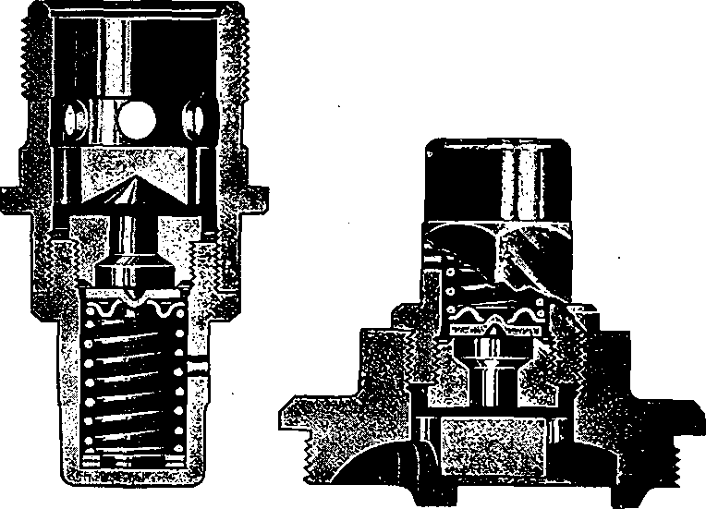
Plates 1 and 2, is to relieve the pressure acting on the low pressure air piston, should it exceed the normal amount due to back leakage past the intermediate discharge valves. In the event of the development of excessive pressure, valve 158 is unseated against the force of spring 161, which opens a passage between the air cylinder and the exhaust port in the relief valve body. Spring 161 is adjusted to a slightly higher pressure than that normally developed in the low pressure air cylinder, and the relief valve will thus prevent the accumulation of pressure which might interfere with normal operation of the compressor.
Lower Intermediate Valve Cage with Relief Valve
Upper Inlet Valve Chamber Cap with Relief Valve
Fig. 7. Sectional Views of the Relief Valves


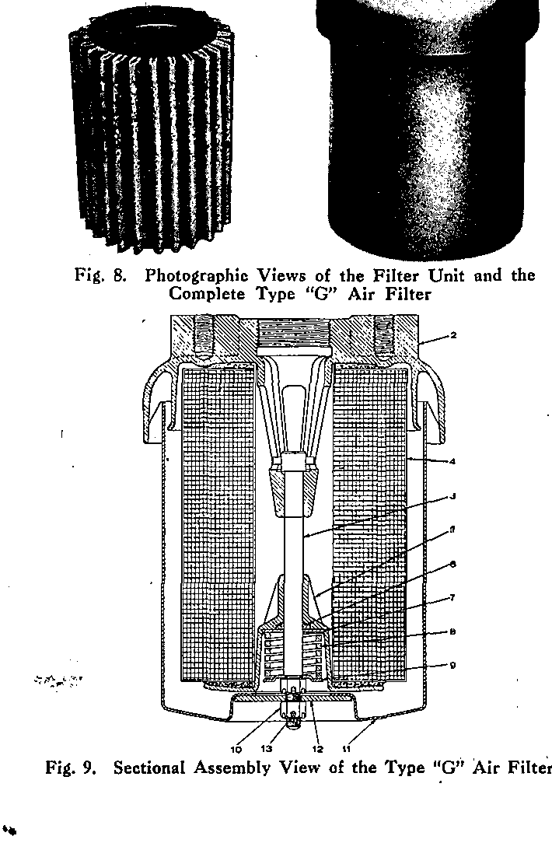

TYPE "G" AIR FILTER
The Type "G" Air Filter is of the "cartridge type" which permits removal of the filter unit without the necessity of dismounting or disconnecting from the air compressor. Fig. 8, illustrates the filter unit and the exterior of the air filter, while Fig. 9 is a sectional assembly "view showing the construction.
The inlet opening is formed in the under side of the cover 2 as an annular ring around the casing 11. As the air enters this opening, it passes upward and inward to the inside of the casing where it strikes a baffle and is directed downward before passing through the filter unit into the discharge opening. Some of the heavier particles of dirt are carried downward and deposited at the bottom of the casing cavity.
The cover is centrally threaded for the pipe connection to the air compressor, and is also provided with two mounting lugs tapped for 3/4 inch studs for mounting purposes. The casing is of pressed steel and is attached to the cover by means of tie bolt 3, washer 12 and nut 10. The casing houses the filter unit and acts as a dirt chamber. In the bottom are several small holes to permit drainage of moisture from this chamber. To- dismantle the air filter for cleaning or replacing the filter unit, it is necessary to remove the cotter and nut from the end of the tie bolt to release the casing, and then a second nut from the tie bolt to release the spring retainer assembly and the filter unit.
The filter unit comprises a corrugated and radial wire mesh assembly, covered with a layer of thick felt so con-

structed that the actual filtration area is many times the inlet or outlet passage areas. This unit is also provided with large felt washers on each end to seal on shoulders surrounding the- outlet passage on the upper end and with the spring cage on the lower end.

No. 54 AIR STRAINER
As will be seen from Figs. 10 and 11, this is a very large double cylindrical strainer (overall dimensions approximately 10"xl4") with an inner strainer of perforated sheet steel, galvanized, and an outer strainer of coarse galvanized wire mesh, the intervening space being well packed with curled hair. A galvanized iron shell encircles the strainer proper, preventing dirt, oil and water from striking directly against the strainer and thereby reducing the possibility of trouble from clogging. The strainer may- be quickly and conveniently taken apart, without disturbing any pipe connections, by removing the nuts from the four studs.
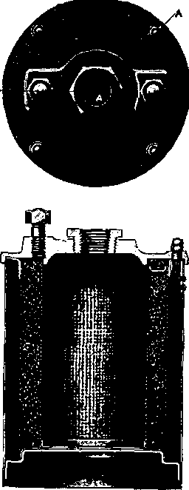
SECTION A-A-A
Fig.-10. Sectional View of the No. 54 Air Strainer

air strainer
27
In order to facilitate cleaning of the strainer between "shoppings" of the locomotive, some roads use a "blow-back" arrangement, as illustrated in Fig. 12. This consists of a 3/4" pipe connected to the main reservoir supply (but not to the discharge pipe), in which is placed a 3/4" cut-out cock having a warning port ^drilled from the outer end of the key into the cored passage so that a small amount of air will discharge when the cock is open and thereby help to guard against it being left open. The cock is placed near the point at which this "connection to the main reservoir supply is made so as to reduce the liability of delay in case Qf pipe breakage beyond the cock. A tee is substituted for the ell at the strainer, and the blow-back pipe is connected through an ell to the tee opening which points vertically upward so that the blast of air will be downward into the strainer. To use the blow-back merely requires opening the cock for a few seconds at any time when main reservoir pressure is at maximum and the compressor is shut off.
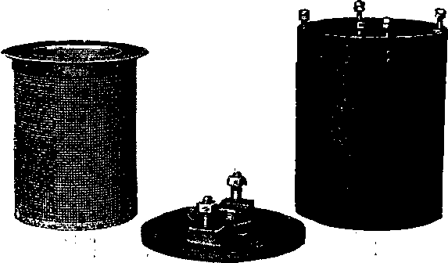
Fig. 11. Disassembled View of the No. 54 Air Strainer

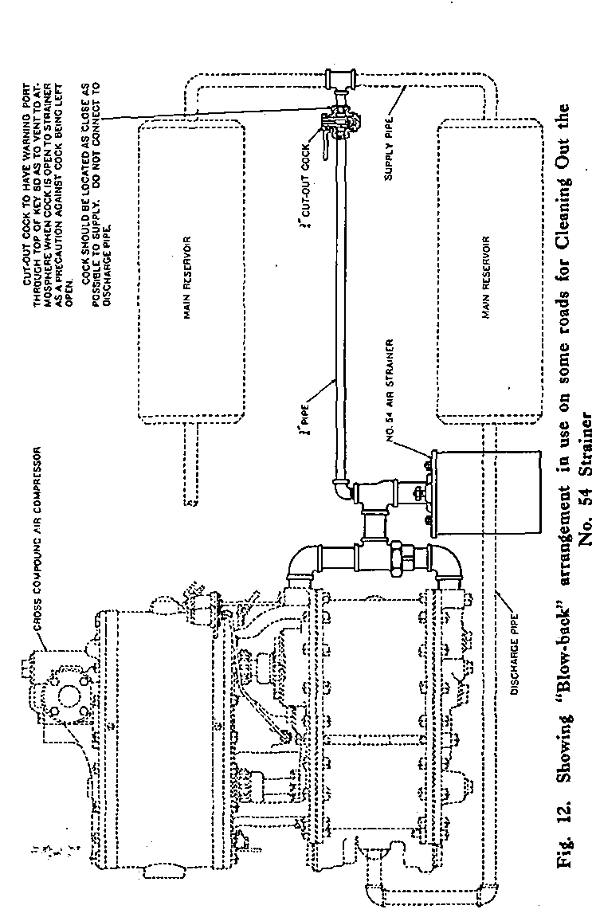

Cage
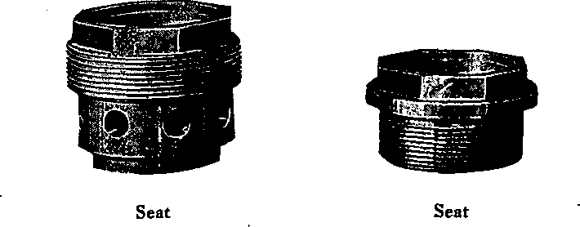
Air Valves, Seats and Gages
Replacements with Westinghouse valves, cages and seats are easily accomplished. Cages, and seats are cut from special grades of steel, each piece made to exact dimensions and the threads, seats, etc., individually checked to insure correct valve lift. Air valves are forged from a special grade of steel bars and then oil tempered to produce a uniform structure. They are individually checked for correct alignment of seat and wings. The seats are spherically ground so that when a new valve is applied to a compressor, it immediately establishes a line bearing fit without any wearing in.

8 1/2" Compressors—General Data
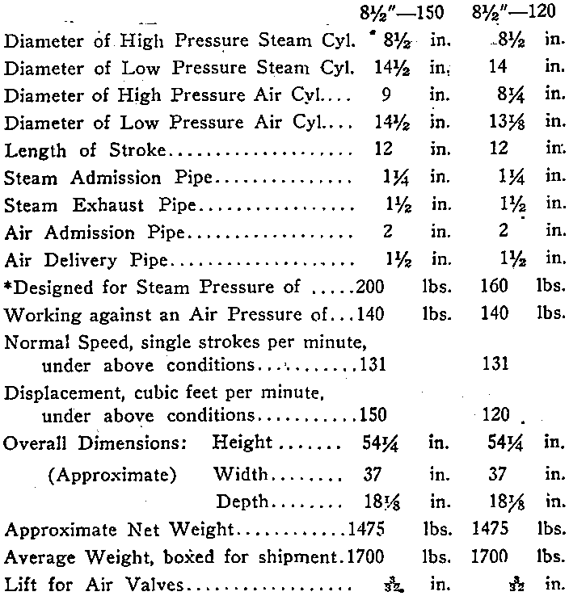
♦NOTE—All 8 1/2 air compressors are designed to operate at approximately 131 single strokes per minute with saturated steam pressure of 200 pounds for the 8%"-150 and 160 pounds for the 8 1/2"-120 compressor. For higher boiler steam pressures, or where steam and air conditions are such as to cause excessive speed of the compressor, it is recommended that a choke fitting be installed In the steam inlet connection. The proper size choke will be specified. upon application to our nearest district office.
Maximum allowable steam pressures are:—275 pounds for the former standard 8 1/2"-150 and 8 1/2'-120 compressors, 300 pounds for the 8 1/2"-150-D and 8 1/2"-120-D compressors, and 400 pounds for the 8 1/2"-150-S compressor.

8 1/2"--- 150 and 8 1/2"—120
Governor in.
Steam Valve 1 1/2 in.
Steam Admission Pipe
Main Pipe 1 1/2 in.
Branch Pipe 1 1/4 in-
Steam Exhaust Pipe
Main Pipe 2 1/2 in.
Branch Pipe 1 1/2 in. ,
Air Admission Pipe See Fig. 13
Air Delivery Pipe
Main Pipe 2 in.
Branch Pipe 1 1/2 in.
10 1/2"
Compressor
Governor 1 1/2 in.
Steam Valve 1 1/2 in.
Steam Admission Pipe
Main Pipe 1 1/2 in.
Branch Pipe 1 1/2
Steam Exhaust Pipe
Main Pipe 3
Branch Pipe 2 1/2 in.
Air Admission Pipe
2" pipe to strainers, or if length of pipe to strainer exceeds 5 feet.
Air Delivery Pipe
Main Pipe 2 in.
Branch Pipe 1 1/2 1n.
NOTE---Compressor Plants tor Industrial service are Illustrated by Installation Diagrams In Instruction Leaflet No. 2341. ,
SIZE OF GOVERNOR, STEAM VALVE AND PIPING FOR TWO COMPRESSOR LOCOMOTIVE INSTALLATION

10 1/2" Compressors—General Data
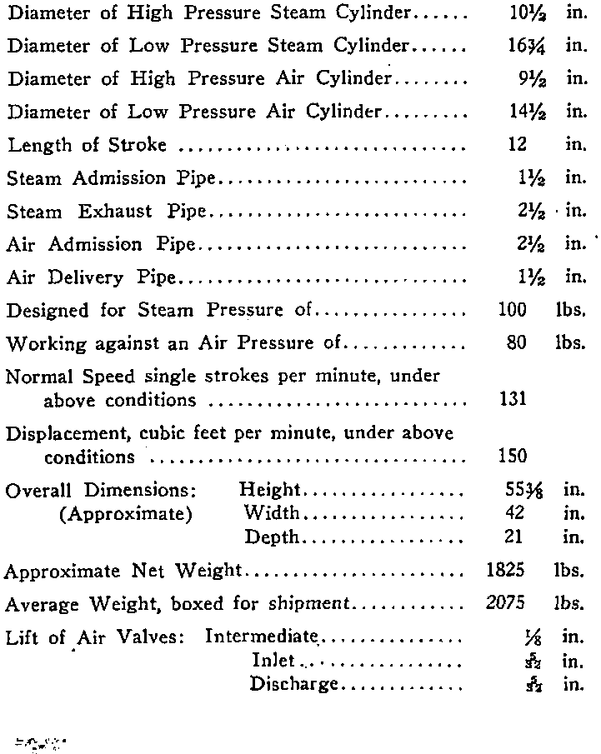
*

INSTRUCTIONS
Piping. All pipes should be hammered to loosen the scale and dirt, have fins removed, and be thoroughly blown out with steam before erecting; bends should be used wherever possible instead of ells, and all sags avoided. A suitable compound to make a tight joint should be applied on the male threaded, portion only, and never in the socket. Do not use red or white lead.
Figs. 13 and 14 show the recommended arrangement and sizes of piping for one compressor and also for a two 8 1/2" compressor installation. The size of the steam supply pipe may be reduced one size when a choke fitting in the . steam inlet is required to limit the compressor speed, as explained by notes under the installation diagrams. This applies to the branch pipes only in a two compressor installation. (The 10compressor being essentially an industrial compressor, the installation diagrams are not included with this pamphlet).
*In a single compressor installation the' governor should be located in the steam supply pipe between the lubricator connection and the compressor in order to insure its receiving the necessary lubrication. The lubricator connection consists of a tee, the side outlet of which connects to the lubricator. In a two-compressor installation the governor should be located in the main steam supply pipe between the lubricator fitting and the steam branch pipe leading to each compressor.
•NOTE—Where the "F-1-A" Mechanically Operated Lubricator is used, these instructions do not apply. See section of this pamphlet covering the "F-1-A" Lubricator.

The intake filter or strainer should be installed vertically, as shown in the various illustrations, and bolted under the running board at some protected point where the cleanest and. driest -air is available—never where a probable steam leak may saturate the air at the intake. Only one intake strainer is requited per compressor and this may be connected to the two inlet openings by piping or by means of a Single Air Inlet Fitting.
Starting and Running. The drain cocks are placed at the lowest points of the steam passages, as shown, for the purpose of draining condensed steam when the. compressor is stopped and when starting it. They should always be left open when the compressor is to stand idle for any length of time. These drain cocks are provided with suitable, union fittings, so that drain pipes may be connected if desired.
In starting the compressor, always run it slowly until it becomes warm, permitting the condensed steam to escape through the drain cocks and the exhaust, until there is sufficient pressure in the main reservoir (25 to 30 pounds) to provide an air cushion. Then close drain cocks and open the steam (throttle) valve sufficiently to rim the compressor at the proper speed, according to circumstances. Racing or running at excessive speeds should not be allowed. The compressor governor automatically controls the starting and stopping of the compressor.
To Stop the Compressor. (1) Close the feed and steam valves on the sight-feed lubricator, if the compressor has a separate one, or the feed, if supplied from the locomotive lubricator; (2) then close the steam (throttle) valve; (3) and open all the drain cocks on the

compressor. Keep the steam valve closed and the drain cocks open when the compressor is not working. The main reservoir drain cocks should also be left open when the compressor is stopped for any length of time. The compressor should always be stopped while the locomotive is over the ash pit. If permitted to run, ashes and dust will be drawn into the air cylinder and injure it, besides clogging up the air strainer.
Lubrication. On account of the high temperatures developed by air compression, the variation between maximum and minimum delivered air pressures, and the necessity of preventing oil from passing into the system, one of the vital problems in efficient compressor operation is to provide a simple means for supplying lubrication to the air compressor in proper quantity and at regular intervals. Non-automatic methods may be employed and satisfactory results obtained as long as care and attention are exercised to provide just enough lubrication to keep the compressor in a properly lubricated condition, but experience has shown that this is very difficult to obtain. The ideal method is obviously that which involves feeding the proper amount of lubricating oil during each cycle of the pistons and causing this feeding of oil to cease when the compressor stops operating; These "automatic" requirements are fully satisfied by the Type "F-1-A" Mechanically Operated Lubricator, with which the only manual operation necessary is that of filling with oil at the required intervals.
See section beginning on page 43 for description, operation, etc., of the "F-1-A" Lubricator.
While the Type "F-1-A" Lubricator is regularly supplied, with cross compound air compressors, many com-

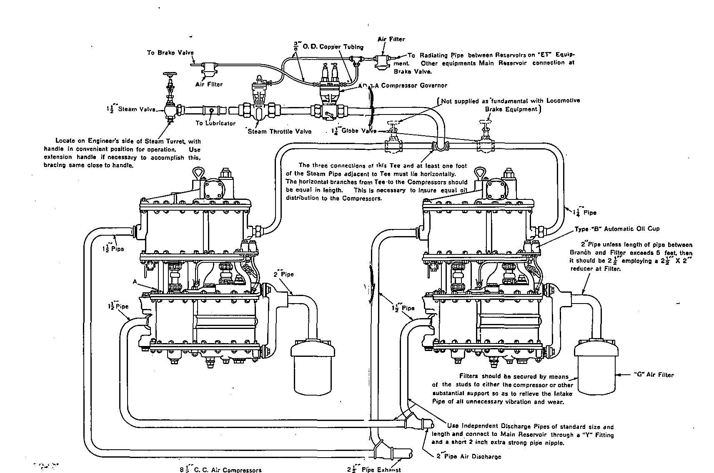
Fig. 13. Installation Diagram of Two Cross Compound Air Compressors
NOTE—When .a choke fitting in the steam inl« is required to limit compressor speed to the normal rate, it is satisfactory to use If inch pipe for the steam supply branch lines instead of 1 1/2 inch pipe as indicated on the diagram.

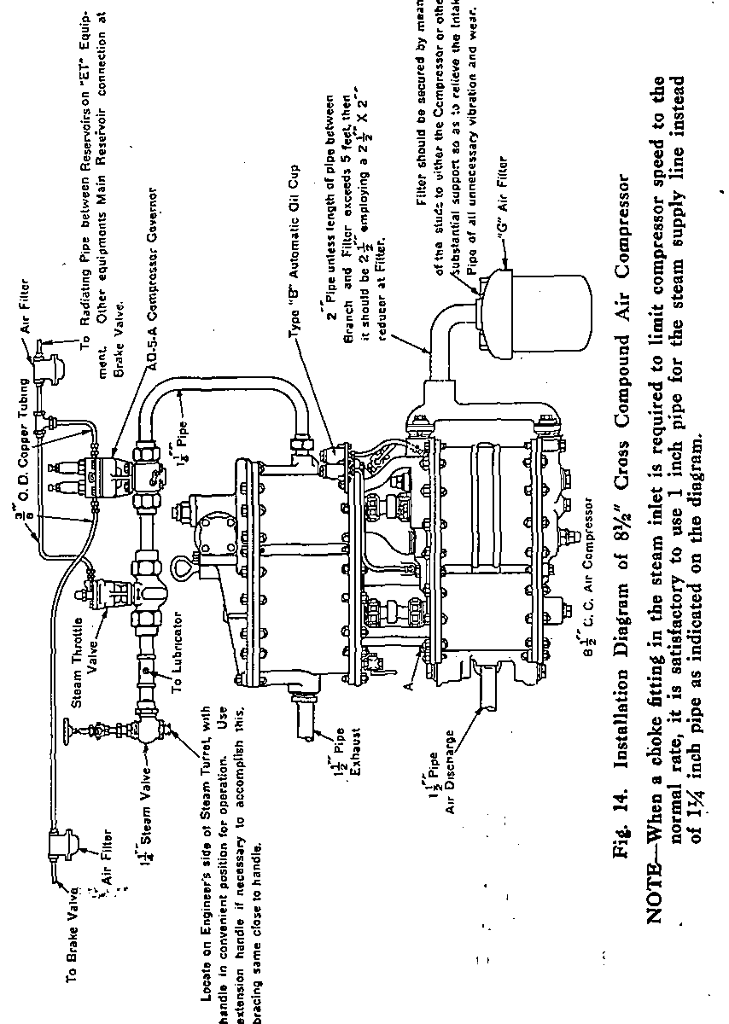

pressors in service are equipped with the Type "B-3" Automatic Air Cylinder Oil Cup.
The construction and operation of the automatic oil cup are very simple, as will be evident from the sectional illustration, Fig. 15. There is an oil chamber a which is filled from the top when the cap nut 5 is removed. The cap nut is provided with a vent hole / so located that when the seal between the cap and body'is broken the air pressure is vented to the atmosphere, thereby permitting the filling operation to be performed while the compressor is running. The stem portion 3 of the body 2 has a central passage b communicating at the bottom with the pipe connection leading to the air cylinder, and at the top with chamber a through the cavity in the cap nut. This passage has its top outlet on the side so as to permit chamber a to be filled without possibility of pouring oil directly into the passage, which would defeat the very purpose of the lubricator.
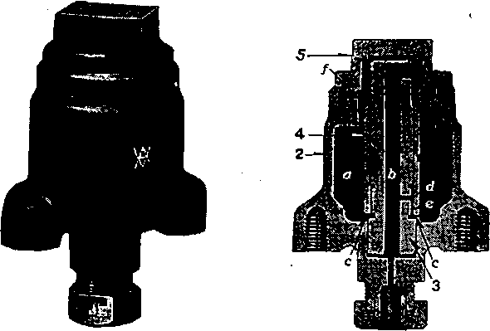
Fig. 15. Exterior and Sectional Views of the Type B-3 Automatic Oil Gup

An oil port d of definite size is located in the stem and connects passage b to an annular feeding cavity e which is formed by a recess in the stem and the neat fitting sleeve, around it. This sleeve has two diametrically placed notches c at its lower end which connect chamber a with cavity e.
When the compressor makes its upward stroke, air is forced up through passage b and into the space above the oil in chamber a.
The lubricant in the cup will flow through the notches "c" into the space between the stem 3 and the sleeve 4 and rise in space e by capillary attraction and will then enter opening d to passage b, from which, on the downward stroke of the compressor, the lubricant is carried with the flow of the air from the chamber on top of the oil, through passage b into the compressor cylinder. This small amount of oil supplied regularly and reliably is ample to adequately lubricate the air cylinder.
Due to the ability of this type of lubricator to supply minute particles of oil in uniform quantities to the air cylinder of the compressor during each cycle of operation, one filling of its oil chamber will supply sufficient lubrication to the compressor air cylinder for the average trip of a locomotive.
A good grade of standard locomotive saturated steam valve oil only should be used in the air cylinders. Superheater oil is not recommended for air cylinder lubrication because it tends to restrict the air passages, causing the compressor to heat unduly and to wear faster than with the lighter valve oil recommended.

Lubrication—Steam Cylinders. The steam cylinder lubricator (if used) should not be started until all condensation has escaped from the compressor and the drain cocks closed. After closing the drain cocks, start the lubricator to feed in ten or fifteen drops of oil as rapidly as possible, then regulate the feed to about two or four drops per minute for each' compressor. No definite amount can be specified, as the amount of lubrication required depends on the work the compressor has to do, the quality of the steam, condition of compressor, and so on Keep the lubricator feeding while the compressor is running.
A swab, well oiled, is essential on each piston rod.

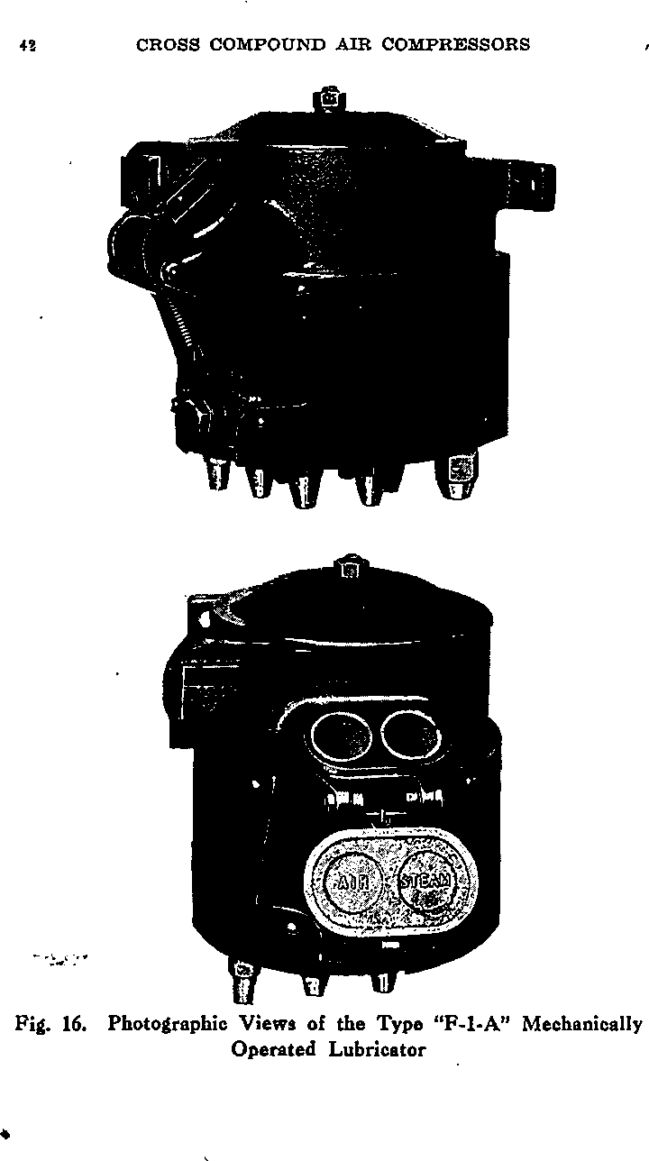

The Type "F-1-A" Mechanically Operated Lubricator is designed to feed the minimum adequate quantity of oil positively to all critical operating parts and"at a rate which is directly proportional to the compressor speed. It is operated by a self-contained pneumatic engine, and is equipped with six adjustable oil delivery pumps and a two chamber oil supply so arranged that different oils may be used for the steam and air ends. Four pumps are connected to one chamber and two pumps to the second but both chambers may be connected together if desired.
Fig. 17 shows a sectional assembly of this lubricator where reference numbers are given to identify the various parts as they will be explained. The pipe connections are also numbered from 1 to 9 for convenience of reference and designation of each pipe as shown on the installation diagrams.
Reference 28 shows the ratchet wheel which is doweled to and readily removable from the oil pump actuating cam 27. Reference 33 shows the operating piston which operates the ratchet wheel by means of pawls 4 and 4a.
The operating cam 27 rotates on a drilled spindle in which there are two lubricating wicks 52 and 53, the lower end of each wick reaching to the bottom of the oil reservoir. The upper end of wick 52 is in a groove in the cam spindle and lubricates the cam bearing by capillary action. Wick 53 extends above the upper plate of the ratchet wheel assembly, and oil drawn up this wick by capillary action flows down the inclined surface of the plate to lubricate the operating and holding pawls at

Fig. 17. Sectional Assembly Views of the "F-l-A" Lubricator
44

their contacts with the ratchet wheel teeth, and then creeps to the pawl pivots and on to the operating piston to lubricate these parts.
A sectional view of one of the oil pumps is illustrated in this drawing, Fig. 17. Each of the six pump unite consists of a cylinder body 7, plunger 9, plunger spring 12, two ball check discharge valves 15 and 19 in series, discharge fittings with" choke 21, and plunger stroke adjusting nuts 14. The plunger spring 12 is secured on the plunger 9 by spring retainer 11 in such a manner that the force of the spring acts to keep the plunger 9 to the lowest point in its cylinder that adjusting nuts 14 will permit.
Reference 40 shows the close mesh strainers provided in the entrance to the oil chambers to prevent foreign matter from being carried in with the oil supply. Additional close mesh strainers 8 are provided around each individual oil pump intake as a further protection against sediment in the reservoirs entering the oil pumps. One oil reservoir has one-half the capacity of the other, the small reservoir supplying two oil pumps for lubricating the air cylinders of the compressor, and the large reservoir supplying four oil pumps for lubricating the steam cylinders of the compressor and the governor and throttle valve. The separate oil reservoirs, as previously stated, permit the use of a different type of oil in the steam and air cylinders. When the same oil is used for both the steam and air ends of the compressor, both reservoirs may be connected together by removing plug 3. Removal of cap nut 26 drains the large reservoir, and the small reservoir may be drained by removing plug 3.

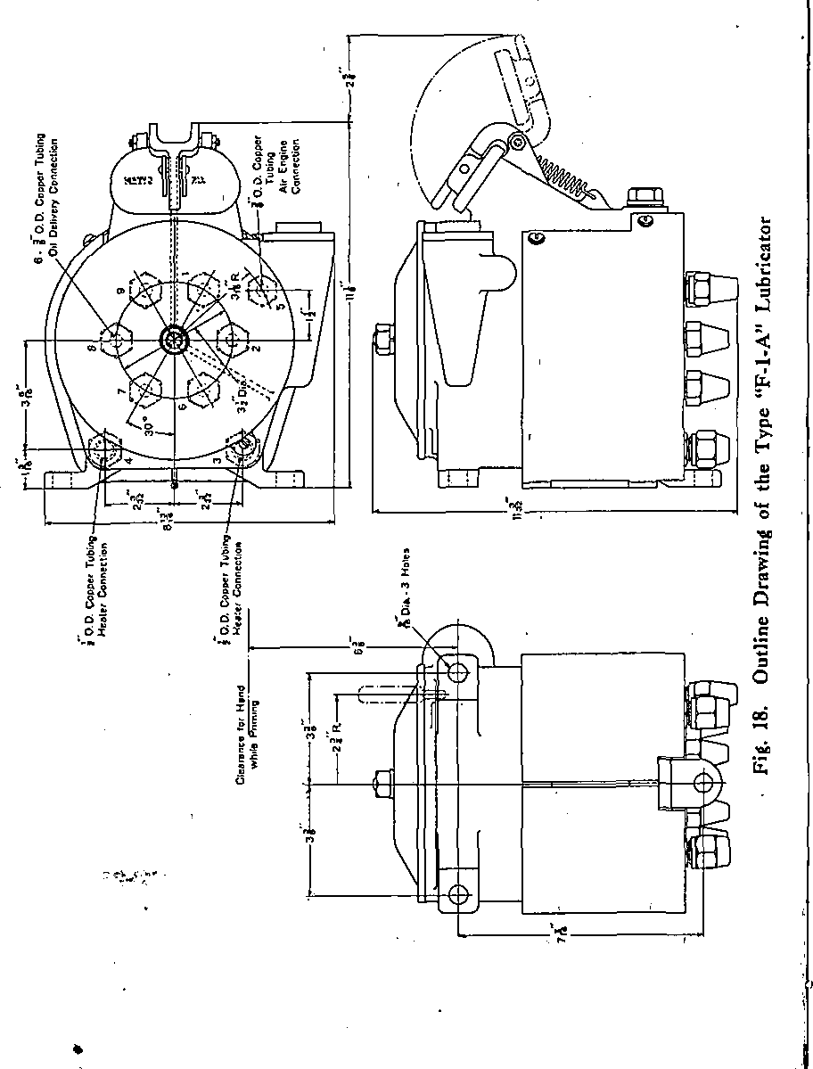

A heating chamber, which is connected to the steam exhaust pipe of the compressor, is provided to keep the oil in the lubricator at a proper temperature to insure satisfactory operation. Lagging is applied to the body of the lubricator to afford additional assurance that the oil is maintained at a proper operating temperature when the lubricator is exposed to low temperatures. This lagging is held in place by a suitable removable metal covering secured to the body of the lubricator.
While the standard construction has six oil pumps, if any of these are not required for a particular installation, they can be omitted and their outlets blanked with a blanking disc.

Operation
Referring to section assembly views, Fig. 17, as the low pressure air piston of the compressor moves up, air pressure is developed on the face of the lubricator operating piston 33 and moves it against the force of piston spring 38, carrying with it pawl 4a, which engages with a tooth in ratchet wheel 28. This rotates the ratchet wheel two notches, and pawl 4 drops into a tooth of the ratchet wheel to prevent the wheel moving backward. On the down stroke of the compressor low pressure air piston, the pressure is reduced on the face of operating piston 33, and spring 38 returns the piston and attached pawl to their original position;
The ratchet wheel, as previously stated, is attached to the cam 27. The upper side of the cam flange is an inclined plane, and as the cam is moved, the thin edge of the inclined plane enters a slot in the plunger rod. As the cam continues to move, it lifts the plunger in its

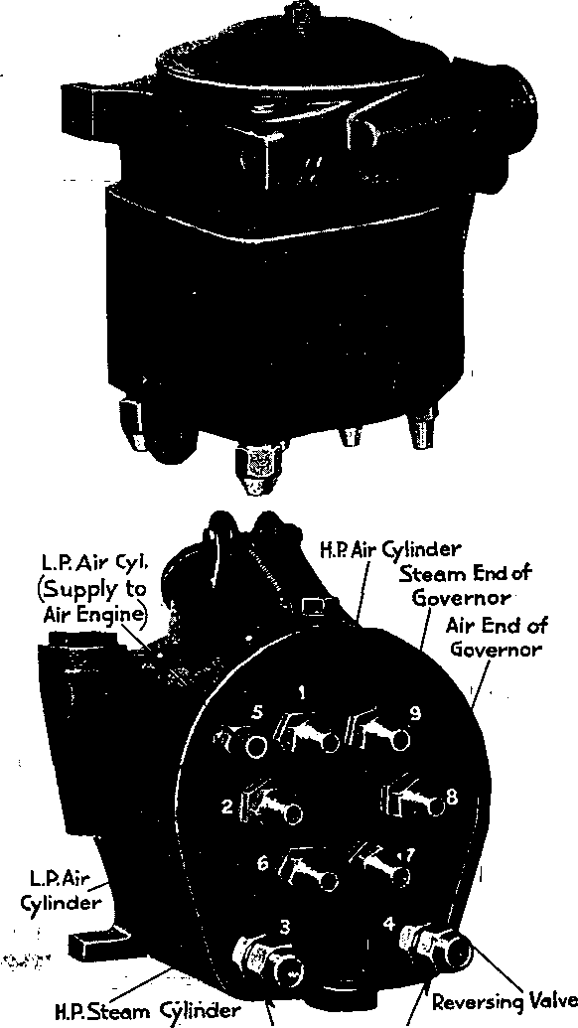
Heater Connections 19. Photographic Views of the Type "F-1-A" Mechanically Operated Lubricator

cylinder, above the intake port a and the oil from the reservoir flows into the pump cylinder, filling the space above discharge ball check 15. When the cam passes out of the plunger rod slot, spring 12, now free to act on the plunger, forces it down until it is stopped at the desired stroke by adjusting nuts 14 contacting with the upper end bf the plunger rod guide.
The rapid down-movement of the plunger discharges the oil in the oil pump cylinder at high pressure and forces it past the two discharge ball check valves 15 and 19, through the delivery pipe to the compressor or governor fitting and past the non-return check in the terminal fitting to the part to be lubricated.
Each of the six plungers makes one stroke during a complete revolution of the ratchet wheel which occurs during 50 double strokes of the compressor.

Adjustment
The amount of oil delivered per stroke is controlled by the distance the plunger is allowed to move downward, the adjustment being made by means of adjusting nuts 14. To increase the amount of oil delivered, the nuts are turned to the left and to decrease the oil delivered, the nuts are turned to the right. After adjustment the two nuts are tightened together or "locked". In order to change oil feed adjustment, remove nut 51 and lock washer 50 then lift the cover 48. The adjusting nuts 14 are then accessible through an opening in the ratchet wheel. With the older Type F-1 lubricator, it is necessary to remove the ratchet wheel (by means of three screws 31) to expose the adjusting nuts.

Fig. 20. Front View of the Air Compressor with the "F-1-A" Lubricator
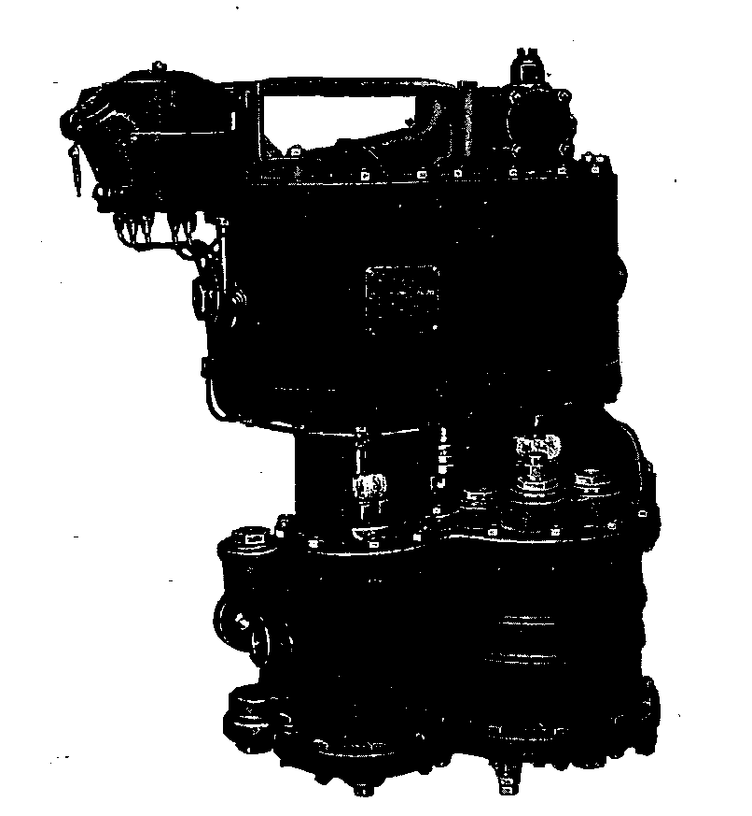

•To check or adjust the length of the plunger stroke, the cam should be turned by use of the primer handle, until the plunger to be checked or adjusted is in its uppermost position. The distance between the lower face of the bottom adjusting nut and upper "end of the plunger rod guide is the working stroke of the plunger. The recommended stroke adjustment of the oil pump-plunger is specified in the following table:
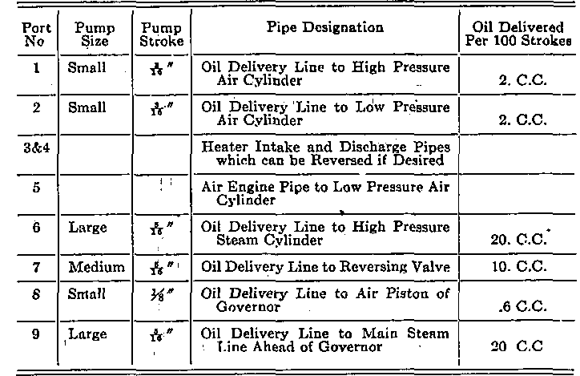
In re-applying when ratchet wheel has been removed, for any reason, care must be exercised to make certain that the pawls 4 and 4a are in place on the teeth of the ratchet wheel and that lubricating wick 53 is above the upper sheet steel plate of the ratchet wheel assembly.

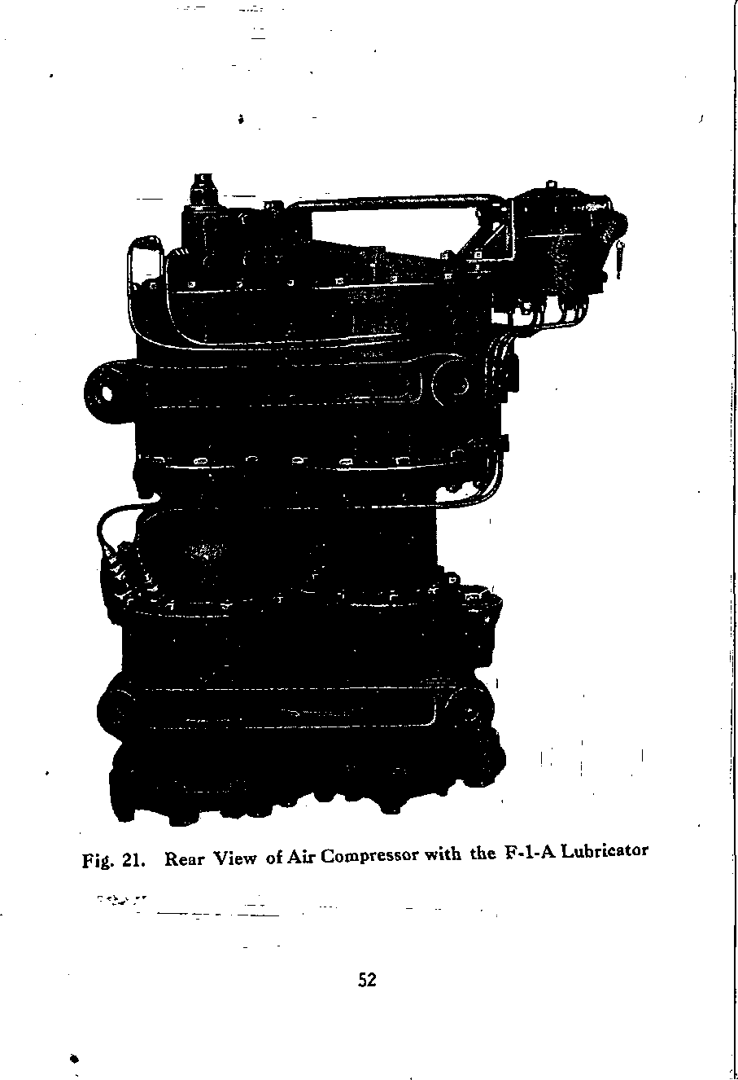

Mounting of Lubricator
The lubricator should be mounted in relation to the air compressor so that all connecting copper tubing shall be as short as possible consistent with avoiding sharp bends. It should be located so that proper drainage of the condensate from the steam heated manifold to an exhaust steam line will be assured. The lubricator connections and corresponding pipes have been numbered from 1 to 9 inclusive, as shown by Figs. 18 and 19. This system of numbers will serve to simplify installation instructions and prevent the possibility of wrong connections when the tubing has been removed for repairs or renewal. The nine connections or ports with their corresponding pipes are given in the table on page 51.
When the method of installing these pipes has been determined it should be recorded in maintenance instructions so that there will be no chance for these pipes being improperly connected during repairs.
When the lubricator is applied to a compressor and before it is operated, the delivery tubes must be filled with the proper oil. This can be accomplished either by filling the tubes before they are attached to the lubricator or after they are attached by turning the lubricator by hand for a sufficient time to fill the tubes. It has been found that at least 80 turns of the ratchet wheel are required for the recommended tubing if the tubes are not initially filled with oil. The alternate tubing with greater volume or tubing of unusual length will require more. If the tubes are filled, the ratchet wheel should be turned at least ten times to prime the pumps before the compressor is started.

Hand operation of the lubricator is accomplished by removing the top cover 48 and applying the priming handle 29 (Fig. 17) to the hole provided in the ratchet wheel. This handle is furnished with the lubricator. The priming handle must be removed and the top cover replaced and secured after this operation has been completed.
Lubricating Oil
It is imperative that only high grades of lubricating oils of a suitable type and viscosity be used in this lubricator to obtain proper lubrication of the compressor and associated devices. Since in general, each user has his own specifications for oil, no attempt is made here to provide a specification. If desired, however, W. A. B. Co. specifications for recommended lubricants will be supplied upon request.
Maintenance and General Care
The strainer in the filler inlets should be removed and inspected from time to time and cleaned if necessary. When the lubricator is removed for general inspection, it should be subjected to prescribed tests before being returned to service. Care must be exercised to replace each pump in the cylinder from which it was removed.

The Interstate Commerce Commission's "Rules and Instruction for Inspection and Testing of Steam Locomotives and Tenders" dated 1919, specified as follows regarding steam compressor tests:
"The compressor or compressors shall be tested for capacity by orifice test as often as conditions may require, but not less frequently than once each three months."
The above Rules and Instructions also specify that with a 9-32" orifice to atmosphere and main reservoir pressure maintained at 60 pounds, the compressor must make not more than 100 single strokes per minute. For altitudes over 1,000 feet, the speed of the compressor may be increased five single strokes per minute for each 1,000 feet increase altitude.*
We recommend the following method for making the above test:
Before making any test, the main reservoir should be drained and it and its connections should be tested for leakage as follows: After obtaining the main reser voir pressure corresponding to the governor setting, close the throttle to the compressor. Then close the main- reservoir cut-out cock when the SD (or SF) governor is used; if, however, the SG type of governor or the SF type with a manifold providing for a single main reservoir
•NOTE—The above figures are for ,the —160 compressor only. The use of a if" diameter orifice to atmosphere with the
—120 compressor, other test conditions remaining the same, will provide approximately the same relative condemning point for this machine.

connection to the governor is used, leave the main reser- 'voir cock open and close the brake pipe cut-out cock under the brake valve and the cut-out cock in the supply pipe to the distributing valve and place the brake valve handle on lap. If no cut-out cock is used, as with the A-l Equipment, place the brake valve handle on lap. Bleed down reservoir pressure to about 62 or 63 pounds. Allow the pressure to leak down to 60 pounds (that is, to settle down to an equalization of tempera-
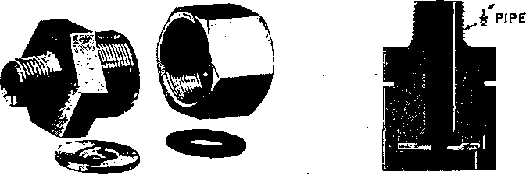
Fig. 22. Disassembled View and Sectional View of Disc Holder with Disc
tures) and note the amount of drop from this pressure during one minute. This drop must not exceed 2 pounds. If a greater leakage than this exists, it must be reduced to this limit before proceeding with the compressor test, otherwise the test would indicate a poorer condition of the compressor than is the case, due to extra labor required to maintain this leakage.
After the main reservoir and its connections have been tested for leakage as above, the compressor should be tested as follows:
The orifice disc is placed in a special holder, Fig. 22, supplied for this purpose which should be connected to the main reservoir drain cock, as illustrated in Fig. 23,

with a test gage inserted between the disc holder and drain cock. Then close the main reservoir cut-out cock if the SD (or SF) governor is used; if, however, the SG type of governor or the SF type with a manifold providing for a single main reservoir connection to the governor is used, leave the main reservoir cock open and close the brake pipe cut-out cock under the brake valve and the cut-out cock in the supply pipe to the distributing valve and place the brake valve handle on lap. If no
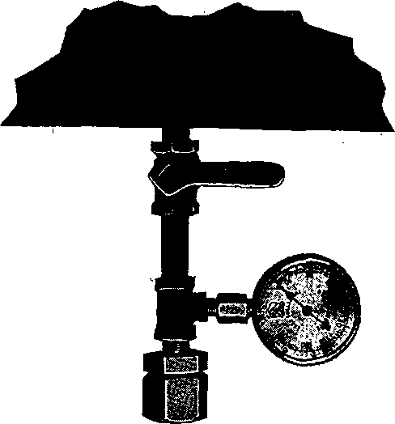
Pig. 23. Showing Orifice Disc Holder and Gage Connection to Main Reservoir Drain Cock
cut-out cock is used, as with the A-l equipment, place the brake valve handle on lap. Then start the compressor and raise the pressure in the main reservoirs to slightly below 60 pounds. Open the drain cock to the orifice and throttle the steam supply to the compressor until

58
cross compound air compressors
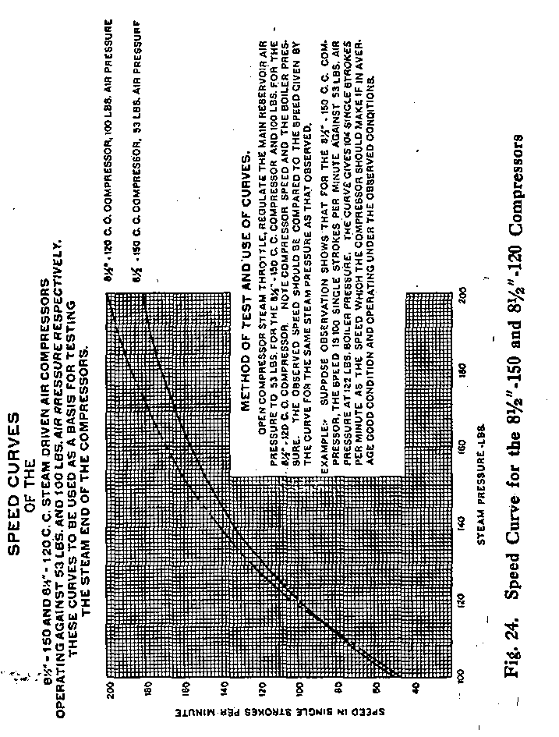

the main reservoir pressure is maintained at approximately 60 pounds. Then count the strokes of the compressor required to maintain this pressure during one minute. This number must not be in excess of 100.
During the tests it should be assured that boiler pressure- is at all times at least sufficient to obtain the required number of strokes against 60 pounds air pressure when the throttle to the compressor is full open.
Test of Steam End
While the Interstate Commerce Commission makes no mention of tests of the steam end, such tests should be made to determine whether or not the efficiency of the steam end of the compressor is lower than warrants continuing it in service or after having been repaired and over-hauled, it is in proper condition to be returned to service.
The test specifications given hereinafter are based upon the performance of a number of compressors in what may be termed a good average condition. It should be understood that the limits specified are neither those which should condemn a compressor nor necessarily the best performance which should be expected from a compressor in the best possible condition. The condemning limit should be established by those familiar with existing service requirements. The tests specified merely indicate the method which we would recommend.
In establishing a minimum passable performance of the compressor, it should be borne in mind that this limit should not be set too low. This is to prevent the compressor getting into such poor condition as to require expensive repairs. For this reason, we strongly

recommend that the condemning limit should never be established below 75 per cent, for the steam end of the tests specified hereinafter, no matter what the service may be or the apparent ability of the compressor to meet operating requirements, even with a considerably lower efficiency than this. Where operating conditions demand a more rigid requirement, the condemning limit should be raised to an amount determined by the judgment of those in charge.
The steam end of the compressor should be tested in the following manner:
The compressor steam throttle should be opened wide and the main reservoir pressure should be regulated by means of a cock or valve leading to the atmosphere until the pressure in the reservoir reaches 53 pounds. When this pressure has been obtained, the locomotive boiler pressure and the compressor speed in single strokes per minute should be observed and compared with that shown on the curves, Fig. 24, which represent what the performance ought to be if its steam end is in good average condition.
For example, suppose with the steam throttle opened wide and the main reservoir pressure maintained at 53 pounds, by bleeding it to the atmosphere at a given rate, observations show that a speed of 100 single strokes per minute is attained with a boiler pressure of 122 pounds. The curves show that, if the steam end is in good average condition, the 8 1/2"-150 compressor operating against a main reservoir pressure of 53 pounds, with 122 pounds boiler pressure, should make 104 single strokes per minute, and that the 8 1/2"-120 compressor operating against a main reservoir pressure of 100 pounds, with 122 pounds

boiler pressure, should make 110 single strokes per minute. If the observed speed is less than that indicated on the curves for the given conditions, the judgment of those in charge should determine whether the compressor should be over-hauled.
If the condemning limit for the steam end has been set at 75 per cent of the performance of a compressor in good average condition, the speed of the compressor should not be less than 75 per cent of the speed called for by the curve at a point corresponding to the particular condition of steam pressure under which the compressor was tested. For instance, in the case under con- sideration, the compressor should have a speed of not less than 75 per cent of 104 strokes, or 78 single strokes per minute.

DISORDERS Causes and Remedies
NOTE: Experience has demonstrated that the "major portion of compressor disorders is caused by lack of proper lubrication and the entrance of dirt which results in the formation of carbon. These disorders are practically eliminated with the use of the "F-1-A" mechanically operated lubricator and the Type "G" air filter, providing these two devices are properly maintained in normal operating condition.
Compressor Refuses to Start. Cause:—Insufficient oil, due to improper feed of lubricator, or oil washed out of cylinder by water of condensation; leaky piston rings in the small end of the main valve piston; or rust having accumulated during time compressor has lain idle. Remedy:—shut off steam, take off reversing valve cap, pour in a small quantity of oil, replace cap, and then turn on steam quickly. In many cases when the compressor will not start when steam is first turned on, if steam is then turned off and allowed to remain off for one or two minutes, arfd then turned on quickly, it will start without the use of any oil, except that from the lubricator.
Compressor Groans. Cause:—(1) air cylinder needs oil. Remedy:—(1) put some oil in air cylinder. Cause:—(2) piston rod packing dry and binding. Remedy:—(2) saturate piston swab with oil. Cause:— (3) steam cylinder needs oil. Remedy:—(3) adjust lubricator to correct feed.
Excessive leakage past the air piston packing rings, or "past a discharge valve, causes heating, destroys lubrication and results, in groaning.

disorders 63
Uneven Strokes of the Compressor. Cause:— probably (1) sticky air valves; (2) improper lift of air valves; (3) clogged discharge valve passages; (4) clogged strainers under upper intermediate valves ; (5) leaky air valves; or (6) binding or cutting of the reversing rod. Remedy:—locate cause, if possible, and correct it by cleaning out clogged or dirty passages, air valves and strainers, replacing worn or leaky valves, or straightening or replacing the .reversing rod.
Slow in Compressing Air. Cause:—(1) leakage past the air piston packing rings, due to poor fit, or wear in cylinder or rings; (2) valves and passages dirty; or, (3) air filter clogged. Remedy:—(1) and (2) To determine which is causing the trouble, obtain about 90 pounds air pressure, reduce the speed to 40 or 60 single strokes per minute, then listen at the "Air Inlet Openings" and note if air is drawn in during only a portion of each stroke, and if any blows back. (Note:—When both air inlet openings are connected to a common air inlet manifold, it is necessary to disconnect the air inlet manifold before making this investigation). If the latter, an inlet valve is leaking. If the suction does not continue until each stroke is nearly completed, then there is leakage past the air piston packing rings or back from the main reservoir past the air discharge valves. Remedy:—(3) clean air filter thoroughly. . .
Compressor Heats. Cause:—(1) air passages are clogged; (2) leakage past air piston packing rings; or (3) the discharge valves have insufficient lift. Remedy: —(1) clean air passages; (2) renew air piston rings; (3) regulate lift of discharge valves to 3-32 of an inch on the

64
DISORDERS
8 1/2" and to 5-32 of an inch on the 10 1/2" compressor. A compressor in perfect condition will become excessively hot and is liable to be damaged if run very fast and continuously for a long time.
Compressor Pounds. Cause:—(1) air piston is loose; (2) compressor not well secured to boiler, or causes some adjacent pipe to vibrate; (3) the reversing valve plate 18 is loose; or, (4) the reversing rod or plate may be so worn that the motion of compressor is not reversed at the proper time. Remedy:—repair and renew worn parts and tighten loose connections.
Compressor Erratic in Action. Cause:—In addition to the causes of erratic action described in the preceding paragraphs, a worn condition of valve motion, or leakage past the steam piston packing rings, may also cause erratic action. Remedy:—renew the worn parts.

MAINTENANCE
In connection with the problem of good maintenance for steam driven air compressors of this type, the heating of the air cylinders incident to air compression is perhaps the most important. The operation of the compressor continuously at high speed or against excessive pressures inevitably results in high temperatures which tend to destroy the lubrication, causing the air cylinders to cut, and the groaning of the air compressor, besides filling the discharge passage with deposits from burnt oil, producing undesirable condensation of moisture in the brake system and in general, reducing the overall efficiency of the compressor.
Under normal conditions, the speed should not exceed 140 exhausts per minute, and such a speed should not be maintained continuously for any considerable time as even this speed will cause excessive heating. Continuous running at high speed will cause excessive heating of the air end of the compressor. Overheating from this cause is an indication that a compressor of larger capacity is required.
It is therefore desirable, first, that the compressor be of ample capacity for the service desired (if one compressor does not have sufficient capacity, the obvious remedy is to install two compressors); second, that it be well lubricated and otherwise maintained in good condition, and, third, that leakage from any source whether within the air compressor itself or in the brake system be minimized in every practical way.
One of the most serious leaks is through the air cylinder stuffing box if the stuffing box packing is not prop-

erly maintained, as it not only greatly decreases the air delivered, but the faster speed required increases the heating, and it also causes pounding through loss of cushion. When tightening the packing, do not bind the rod, as to do so will damage both the packing and the rod. Be careful not to cross the gland nut threads.
With two compressors per engine, the separate throttles should be kept wide open and the speed regulated by the main compressor throttle. The purpose is to equally divide the work.
If necessary to replace a broken air valve on the road or elsewhere not permitting of proper fitting, at the earliest opportunity have the repairman replace the temporary valve with another so as to insure the correct angle and width of valve and seat contact, the needed ground joint and the proper lift. The standard lift for all valves of the compressor is 3-32 of an inch; for the 10 1/2" compressor, 5-32 of an inch for the suction and discharge valves and 1/8 of an inch for the intermediate valves. ;When the combined wear of the valve and seat increases this lift more than of an inch, the seat is liable to be injured and the valve broken, with consequent annoyance and delay. For the purpose of readily determining the lift of air valves, an Air Valve Lift Gage, as illustrated in Figs. 25, 26 and 27, may be purchased from us.
To determine the lift of the upper air valve, the gage is first applied to the top flange of the air cylinder, as illustrated in Fig. 25, and the sliding arm adjusted until its end rests against the top of the stop on. the air valve, in which position it is locked by means of the thumb nut.

MAINTENANCE 67
With the arm thus locked, the gage is applied to the valve cap, as illustrated in Fig. 26, and if the valve has proper lift, the under side of the collar of the valve cap will just rest upon the shoulder of the sliding arm, as illustrated. If the gage arm fails to touch the stop on the valve when the shoulder on the sliding bar rests upon the face of the collar, the valve has a lift greater
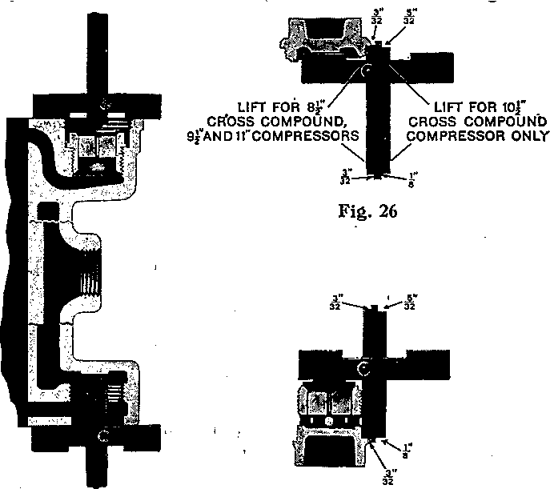
Fig. 25 Fig. 27
than standard by an amount equal to, the distance between the gage arm and the stop. If this lift is greater than the maximum permissible, a repair valve having a long stop should be substituted for the old valve and the stop lowered until the standard lift is reached, as indicated by the gage.

To determine the lift of the lower air valve, the gage is first applied to the bottom flange of the air cylinder, as illustrated in Fig. 25, and the sliding arm adjusted until its end rests against the stop in the cylinder, in which position it is locked by means of the thumb nut. With the arm thus locked, the gage is applied to the air valve cage and air valve, as illustrated in Fig. 27, and if the valve has proper lift, the shoulder on the sliding arm will just rest upon the upper side of the collar of the air valve cage, as illustrated. If the gage arm fails to touch the stop on the valve when the shoulder on the sliding bar rests on the collar face on the cage, the valve has a lift greater than standard by an amount equal to the distance between the stop and the gage arm.
In case the cylinders have been counterbored at the entrance for the valve cage and valve and valve chamber cap in such a way as to interfere with the application of the gage, as above described, it will be found necessary, in order to use the gage properly, to file away the small portion of the ridge so that the cross-bar of the gage will rest on the refaced surface of the valve chamber. In doing this, care should be taken to avoid injury to the refaced surface.
Never remove or replace the upper steam cylinder head with the reversing valve rod in place, as to do so will almost invariably result in bending the rod. A bent rod is very liable to cause a "pump failure."
when installing the reversing valve assembly in the new type top head, it is recommended that the Upper piston first be entered in the cap nut. Then pick up the cap nut and reversing valve assembly and insert the

assembly in the reversing valve bush, observing that each piston with its rings properly enters the bush. If the reversing valve assembly is inserted before applying the cap nut, the reversing valve assembly should be lifted sufficiently to observe that the upper piston rings are properly entered before the cap nut is screwed into place.
When assembling the sections of the main valve, special care should be taken to insure proper alignment and thereby avoid possible trouble from binding of the piston in the bushing.
It is evident that a compressor cannot compress more air than it draws in and not that much if there is any leakage to the atmosphere about the air cylinder. Bearing this in mind, practice frequently listening at the "Air Inlet" when the compressor is working slowly while being controlled by the governor, and whenever a poor suction is noted on either or both strokes, locate and report the fault.
Any unusual click or pound should be reported as it may indicate either a loose piston or a reversing valve plate cap screw or other serious fault.
Any steam leakage that can reach the Air. Inlet of the compressor should be promptly repaired as such increases the danger of water entering the brake pipe.
Keeping the air intake filter clean is of the utmost importance, as even a slightly clogged strainer will greatly reduce the capacity where the speed is at all fast. A seriously or completely obstructed filter, as by accumulated frost, aggravated by rising steam, will increase the compressor speed and will also be indicated by inability to raise or maintain the desired pressure.

GLEANING THE TYPE "G" AIR FILTER
Method of Gleaning Air Filter Unit
At locomotive shopping periods, the filter unit should be removed for cleaning. If the dirt deposited on the convolutions of the strainer is dry, it may be dislodged by jarring the strainer on a hard surface and by the use of compressed air that is free from precipitated moisture. The blast of air should be directed along and not against the outside surface of the convolutions. If the dirt is oily, the strainer should be dipped in an approved alkali-free hydrocarbon solvent, and then subjected to an air blast as previously described. If means are available to spray the fluid on the strainer, this system can be followed to advantage as it avoids excessive absorption of cleaning fluid.

Filter Body
The filter casing should be thoroughly cleaned. If any corrosion is noted, the casing should be wire brushed then dipped in Trichlorethylene or a suitable solvent cleaner. Following the cleaning, the casing should be heated to a temperature of approximately 200 degrees F, after which it should be immersed in NO-OXID at the,same temperature. Remove and drain thoroughly, after which the filter can be re-assembled.

Fig. 28. Types "A", "B" and "C" Air Inlet Manifolds


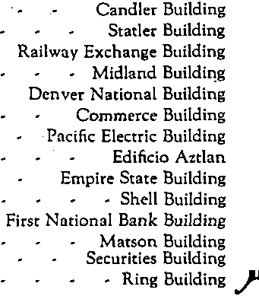
WESTINGHOUSE AIR BRAKE COMPANY AIR BRAKE DIVISION Wilmerding, Pa., U.S. A.
"V



2M-22B

Printed In U.S.A.

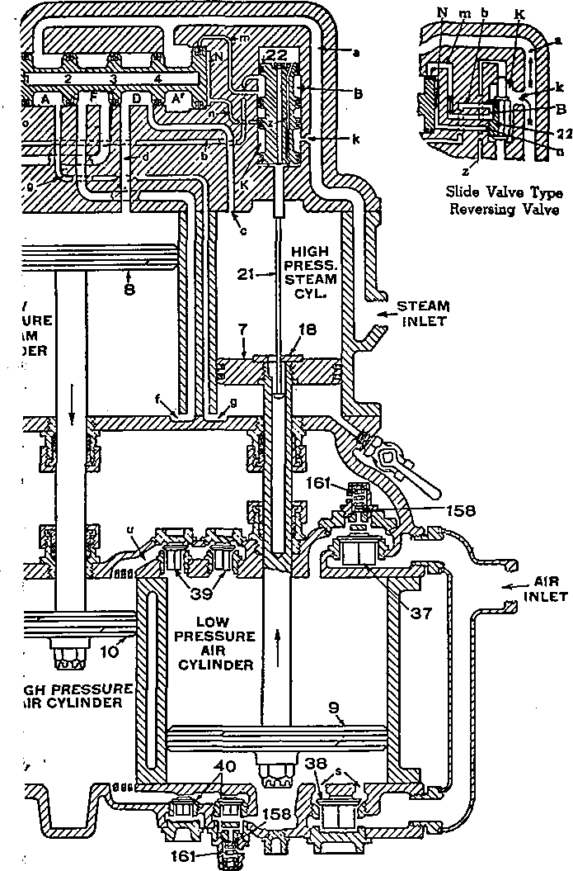
8 1/2" Air Compressor, Diagrammatic, Section. Upward oke of High Pressure Steam (low pressure air) Piston

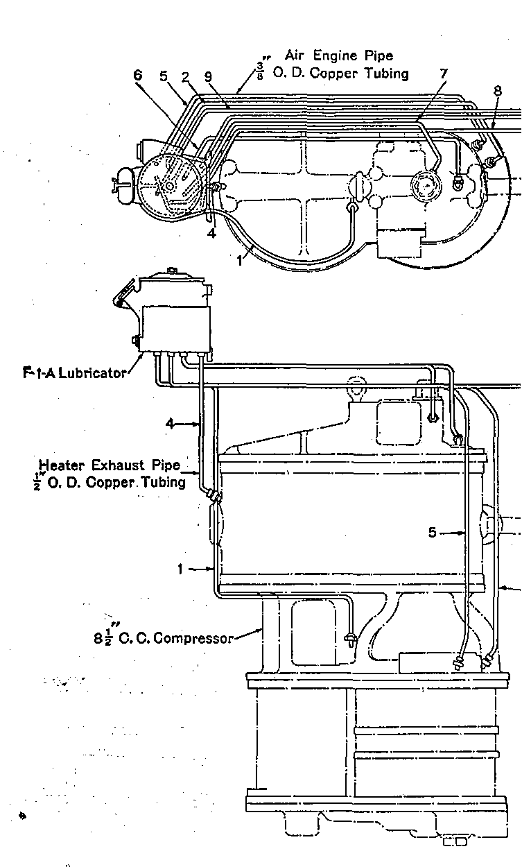

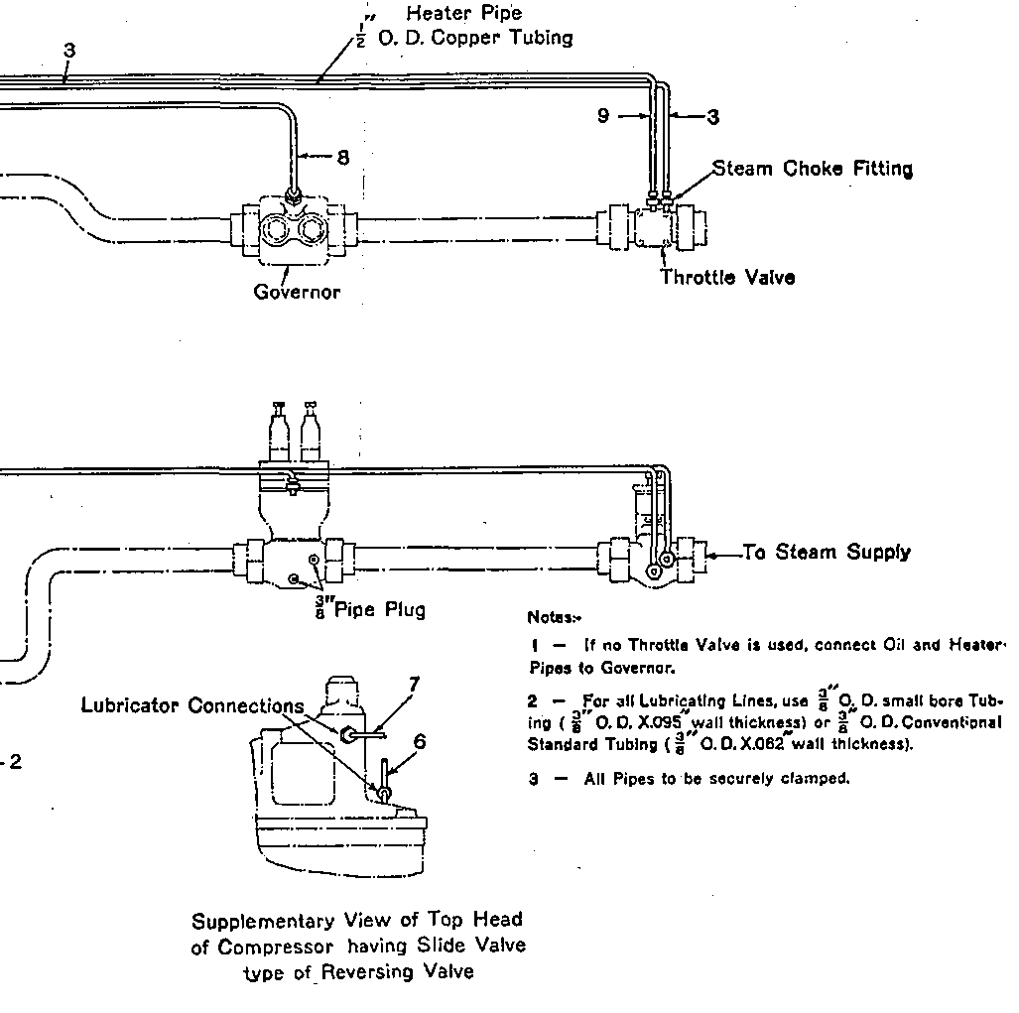
Plate 3. Typical Installation Diagram of "F-1-A" Lubricator as applied to One Standard 8 1/2" Cross Compound Air Compressor

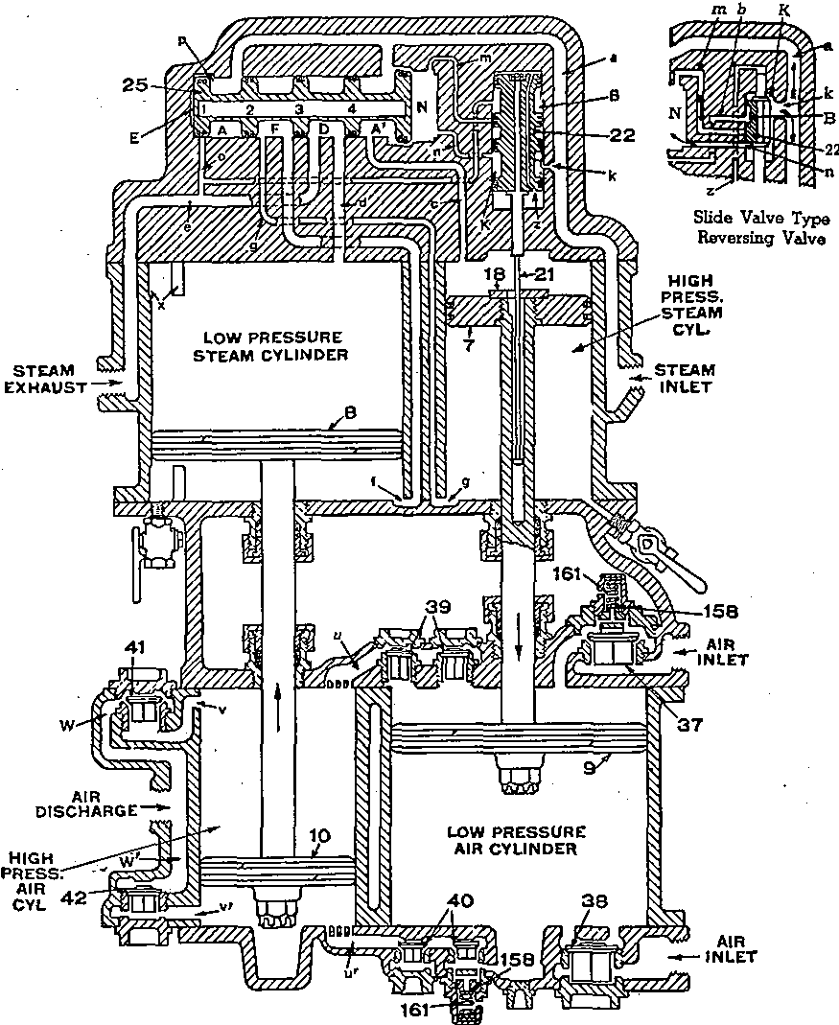
Plate 1. 8 1/2" Air Compressor, Diagrammatic Section. Downward Stroke of High Pressure Steam (low pressure air) Piston

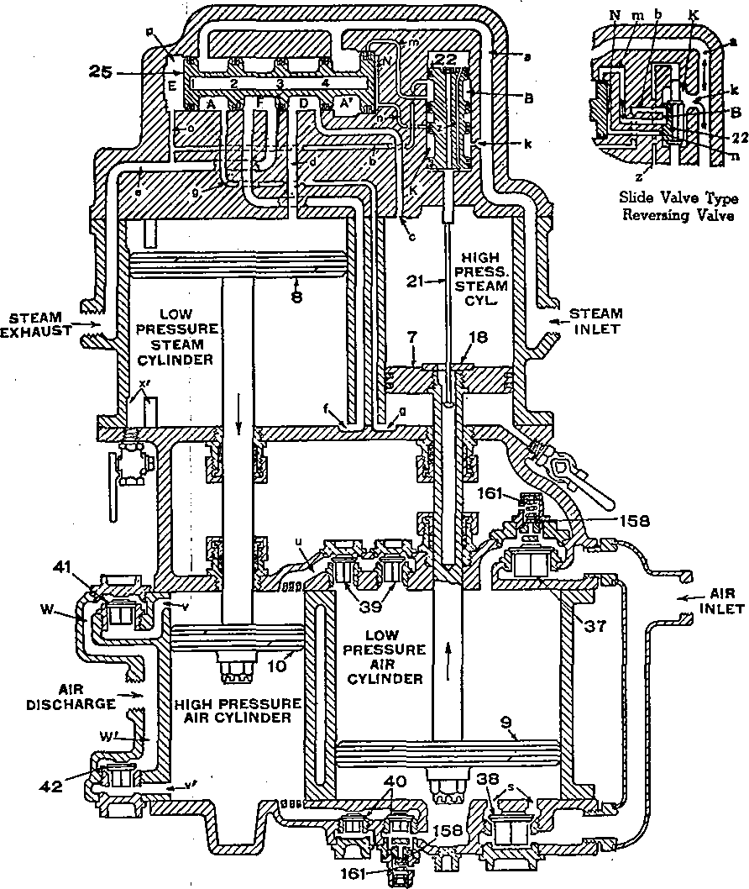
Plate 2. 8 1/2" Air Compressor, Diagrammatic Section. Upward Stroke of High Pressure Steam (low pressure air) Piston

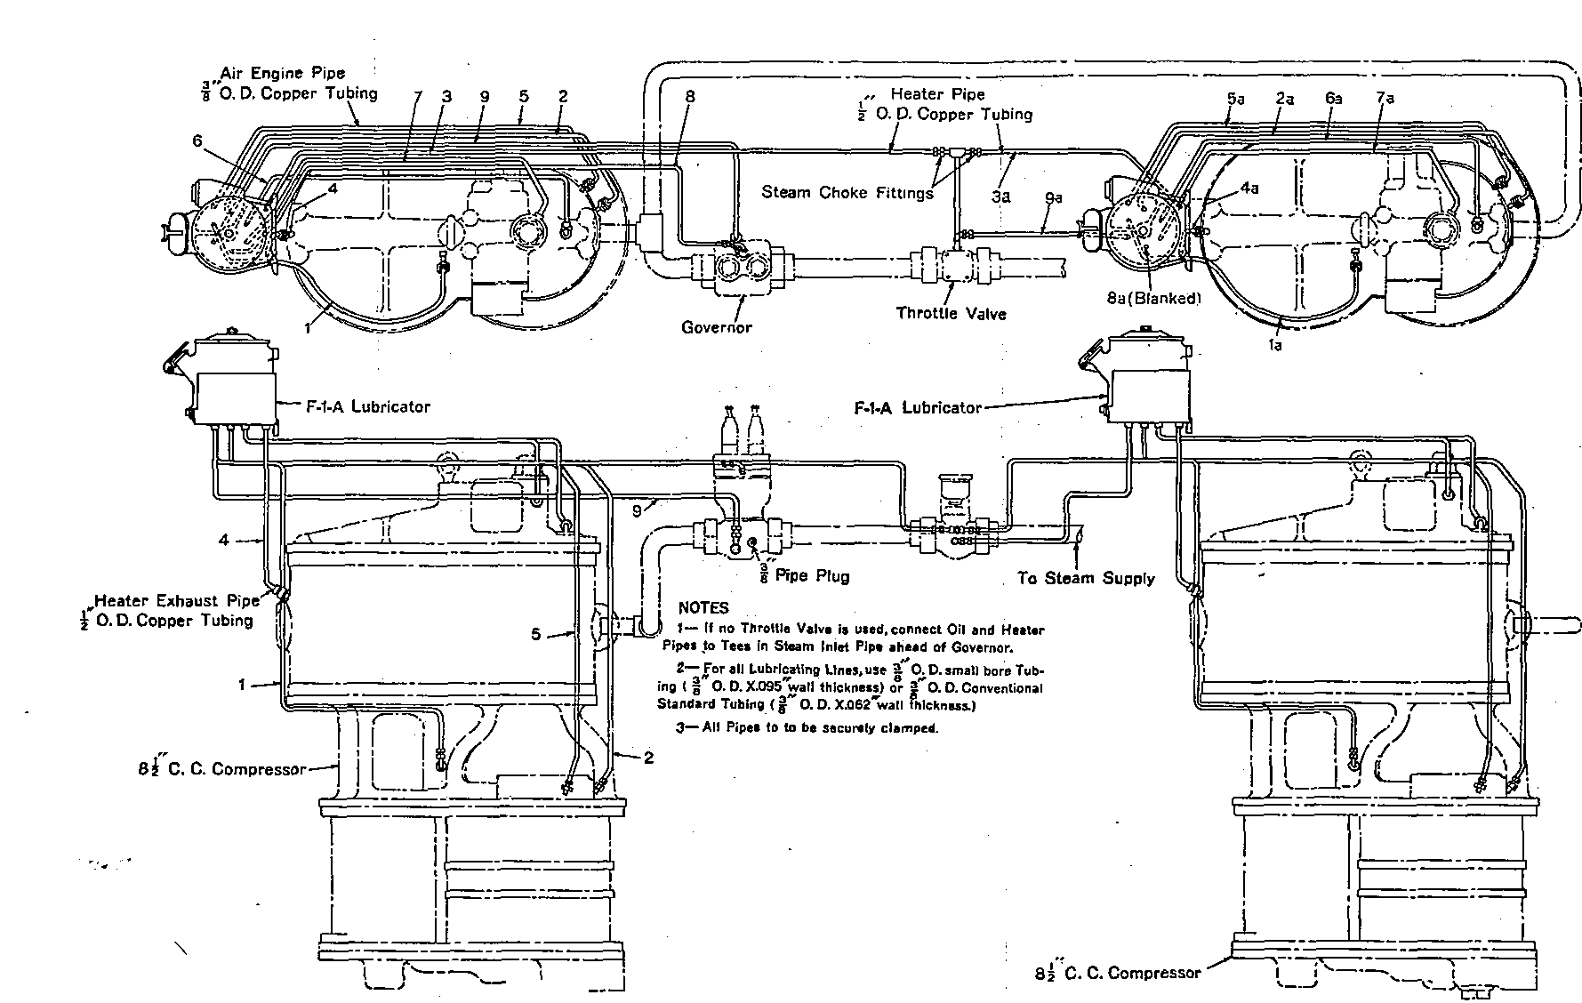

Plate 4. Typical Installation Diagram of "F-1-A" Lubricator as applied to Two Standard 8 1/2

Cross Compound Air Compressors



