SINGLE STAGE STEAM DRIVEN AIR COMPRESSORS
INSTRUCTION PAMPHLET
No. 5036
APRIL, 1942
(Superseding Issue of June, 1931)


CONTENTS
Title Page
General Description 5
Operation . 11
Type "L" Air Filter 17
No. 54 Air Strainer 19
Installation and Operating Instructions. 23

Repair Shop and Road Tests 35
Disorders 41
Maintenance 43

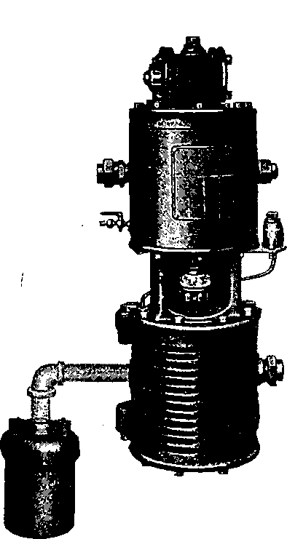
Fig. 1. 9 1/2" Steam Driven Air Compressor

STEAM DRIVEN AIR COMPRESSORS
Simple or Single Stage Type GENERAL DESCRIPTION
NOTE—The reference numbers shown herein are for convenience only and are not to be used when ordering repair parts. See Part Catalogs giving Piece Numbers , etc.
The braking system universally employed in steam railroad service utilizes the expansive force of compressed air for controlling train retardation. The compressed air is supplied by an air compressor, driven by steam, and located on the engine. The "Standard" single stage types of Westinghouse Steam Driven Air Compressors, described in this pamphlet, were designed for this purpose, having particularly in view extreme simplicity, absolute reliability, and low maintenance, as required in this important service.
The compressor consists primarily of (a) an air cylinder, in which the air drawn from the atmosphere is compressed, (b) a steam cylinder, located above the air cylinder, the two being connected by a suitable center piece, (c) steam and air pistons mounted on a common piston rod, and (d) a valve motion controlling steam admission and exhaust. The compressor is double acting, steam being admitted alternately on either side of the
5

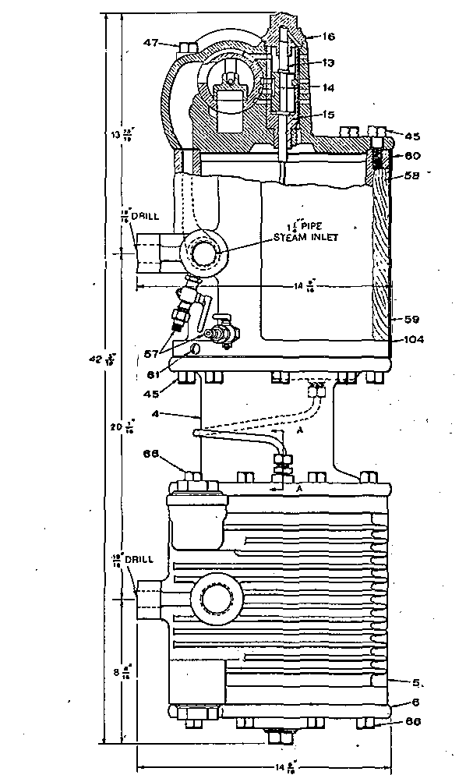
Fig. 2. 9 1/2" Air Compressor outline view with section through the Reversing Valve

steam piston which, being directly connected with the air piston, causes both to move up and down.
On the upward stroke of the air piston the air above it is compressed and discharged into the main reservoir, while the space below is filled with air drawn from the atmosphere. On the downward stroke this operation is reversed. The steam exhaust is piped to the smokestack or to the exhaust cavity of the saddle.
The "standard" single stage compressors are built in three sizes having steam and air cylinders of equal diameter, as follows:
8-inch diameter by 10-inch stroke, called the "8-inch compressor."
9 1/2-inch diameter by 10-inch stroke, called the "9 1/2- inch compressor."
11-inch diameter by 12-inch stroke, called the "11- inch compressor."
The descriptive matter which follows applies equally to the 8-inch, the right-hand 9 1/2-inch, the right-and left- hand 9 1/2-inch, or the 11-inch compressor. The only difference between a right-hand and a right- and left-hand compressor is that with the latter provision is made for reversing the steam and exhaust connections, so that the piping can be conveniently arranged whether the compressor be located on the right or left side of the locomotive. Aside from the steam cylinder all parts of these two patterns are interchangeable.

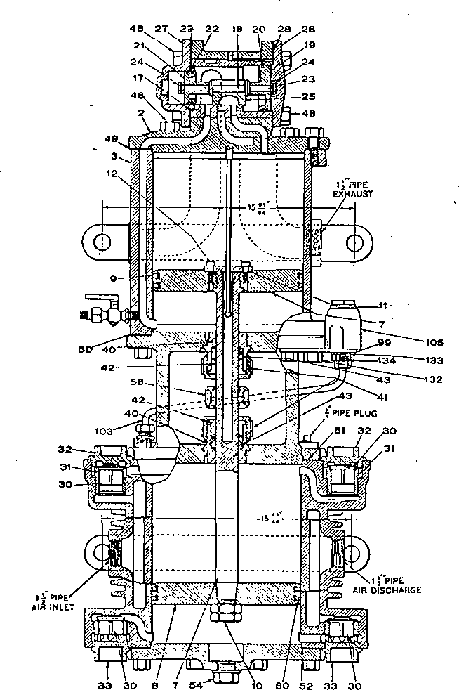
Fig. 3. 9 1/2" Air Compressor sectional assembly view

The following table gives the principal dimensions, displacement, weight, etc, of these compressors.
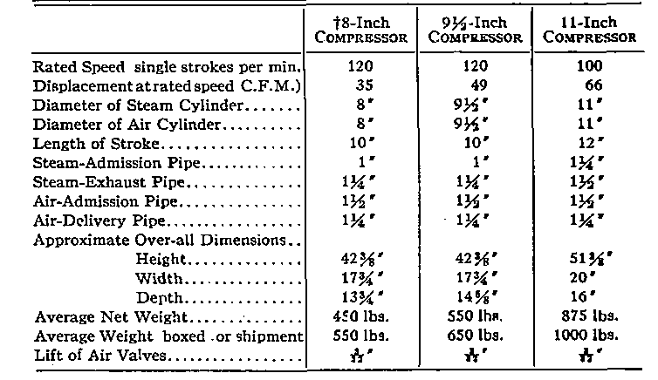
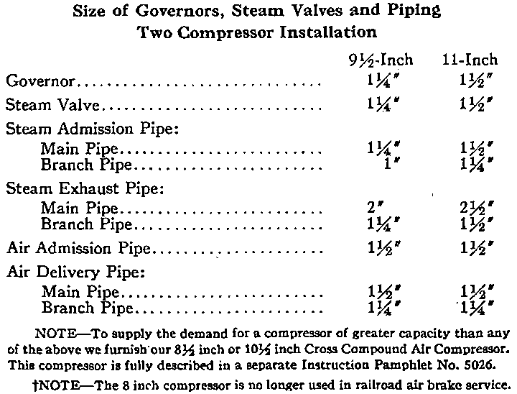

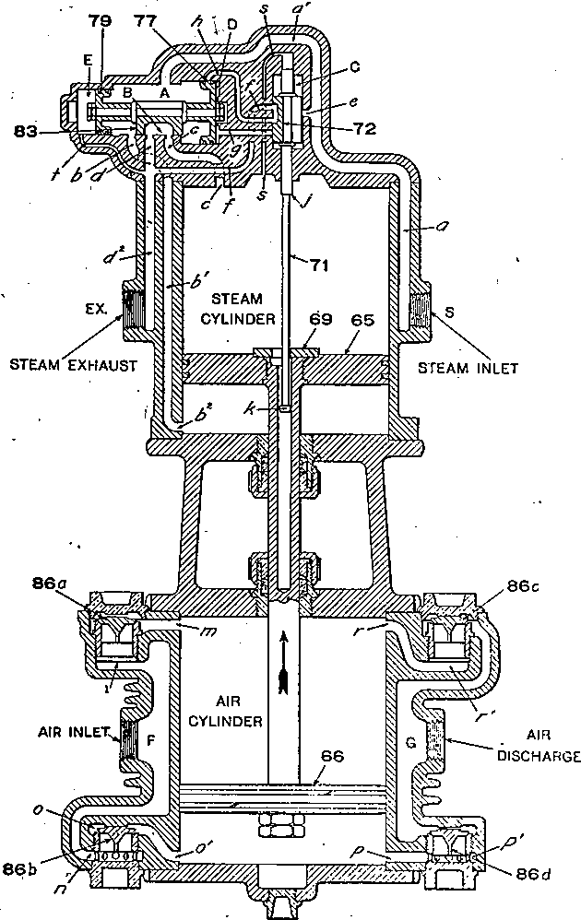
Fig. 4. Diagrammatic View of the Air Compressor, Upward Stroke

OPERATION
Views of the compressor with steam and air cylinders and valve mechanism in section are shown in Figs; 2 and 3. Figs. 4 and 5 are distorted or "diagrammatic" illustrations designed to show as clearly as possible the connections of the various ports and passages but not the actual construction of the parts.
Steam End. Considering first the steam end of the compressor, and referring to Fig. 4, steam from the supply enters at the connection marked "Steam Inlet," and Hows through the passageways a, a', to the chamber A, above the main valve 83 and between the pistons 77 and 79, and through passage e to chamber C in which is reversing valve 72. The supply and exhaust of steam to and from the steam cylinder is controlled by the main valve 83, which is a "D" type of slide valve. It is operated by the two pistons.77 and 79, of unequal diameters and connected by the valve stem. The movement of these two pistons and the main valve is controlled by the reversing valve 72, which is in, turn operated by the main steam piston 65, by means of the reversing rod 71, and the reversing plate 69. As will be seen from the following description, the duty of the reversing valve 72 is to alternately admit steam to or discharge it from chamber D, at the right of piston 77, thus alternately balancing or unbalancing this piston. The reversing valve is operated by the reversing rod 71. This rod is alternately moved up and down by reversing plate 69, which engages reversing shoulder j, on the upward stroke of the steam

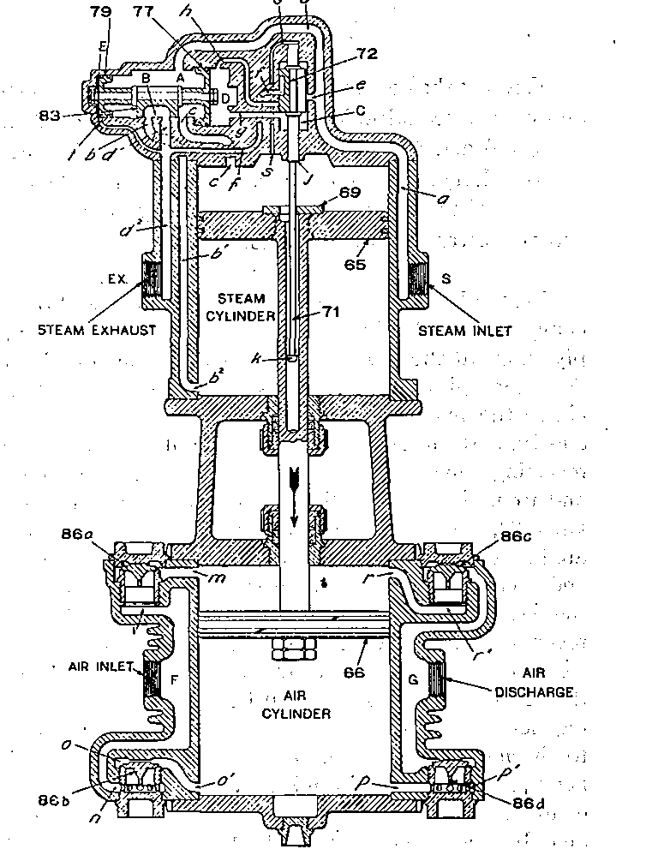
Fig. 5. Diagrammatic View of the Air Compressor, Downward Stroke

piston and button k, at the end of the rod, on the downward stroke.
Chambers A and C, are always in free communication with each other and with the steam inlet through ports a¹ and e, as shown. Live steam is therefore always pres- ent in these chambers, A and C. Chamber E, at the left of small piston 79, is always open to the exhaust passage d², through the port t. Exhaust steam, practically at atmospheric pressure, is therefore always present in chamber E.
A Balancing Port, s, Figs. 4 and 5 runs diagonally to the right in the reversing valve cap nut, and meets a groove down the outside of the reversing valve bush, where it enters the upper end of the cylinder through a small- port in the head. The object of this is to assure the same pressure above as below the reversing rod, whether there is live or exhaust steam in the upper end of the cylinder, thus balancing it so far as steam pressure is concerned.
When reversing slide valve 72 is in its lower position, as shown in Fig. 4, Chamber D is connected-through port h, reversing valve exhaust cavity and port f with main exhaust passage d², and there is, therefore, only atmospheric pressure at the right of piston 77.
Therefore, as Chamber E, at the left of Piston 79, and chamber D, at the right of Piston 77, are then both connected to the exhaust, as already explained, the pressure of the steam in chamber A has driven the larger

piston 77, to the right, and it has pulled the smaller piston 79, and the main valve 83, with it to the position shown in Fig. 4. The main valve 83, is then admitting steam below piston 65, through ports b_{t}b',b². Piston 65 is thereby forced upward, and the steam above piston 65 passes through port c, exhaust cavity B of main valve 83, port d, and passage d²,to connection Ex, at which point it. leaves the compressor and discharges through., the exhaust pipe into the atmosphere.
When piston 65 reaches the upper end of its stroke, reversing plate 69 strikes shoulder j on rod 71, forcing it and reversing slide valve 72 upward sufficiently to open port g (Fig. 5). Steam from chamber C then enters chamber D through port g. The pressures upon the two sides of piston 77 are thus equalized or balanced. Considering piston 79, the conditions are different.'"' Chamber E, as already stated, is always open to the exhaust. As piston 77 is now balanced, the steam pressure in chamber A forces piston 79 to the left, drawing with it piston 77 and main valve 83, to position shown in Fig. 5.
With main valve 83 in this position, steam is admitted from chamber A, through port c, above piston 65 forcing it down; at the same time the steam below this piston is exhausted to the atmosphere through port b², b^{l}, b, exhaust cavity B in the main valve, ports d and d²-, and the exhaust pipe connected at Ex.
When piston 65 reaches the lower end of its stroke; reversing plate 69 engages reversing button k, and draws rod 71 and reversing valve 72 down to the positions

shown in Fig. 4, and one complete cycle (two single strokes) of the steam end of the compressor has been described. <
Air End. The movement of steam piston 65 is imparted to air piston 66 by means of the piston rod. As the air piston 66 is raised, the air above it is compressed, and air from the atmosphere is drawn in beneath it; the reverse is true in the downward stroke.
On the upward stroke of piston 66, Fig. 4, the air being compressed above it is prevented from discharging back into the atmosphere by upper inlet valve 86a. As soon as the pressure in ports r, r', below upper discharge valves 86c becomes greater than the main reservoir pressure above it, the discharge valve 86c is lifted from its seat. The air then flows past this valve down through chamber G, out at the "Air Discharge" and through the discharge pipe into the main reservoir.
The upward movement of the air piston produces a suction or partial vacuum in the portion of the cylinder below it. The air pressure below piston 66 and on top of the lower left-hand inlet valve 86b becomes, therefore, less than that of the atmosphere in port n underneath this valve. Atmospheric pressure therefore raises valve 86b from its seat, and atmospheric air is drawn through strainer, at the "Air Inlet," into chamber F, and port n, below the inlet valve 86b, thence past that valve and through ports 0 and 0' into the lower end of the air cylinder, filling same. Air cannot enter this part of the cylinder by flowing back from the reservoir through passage G and lower discharge valve 86d, since this valve

is held to its seat by the main reservoir pressure above it. The lower inlet valve 86b seats by its own weight as soon as the up stroke of the air piston 66 is completed.
On the downward stroke of the, compressor, Fig. 5, the effect just described is reversed, the air below piston 66 being compressed and forced out through ports p and p', past lower discharge valve 86d and through chamber G and the air discharge pipe into the main reservoir.. At the same time air is being drawn in from the atmosphere through the "Air Inlet" through chamber F and port I, upper inlet valve 86a and port m into the upper end of the air cylinder above the air piston 66.
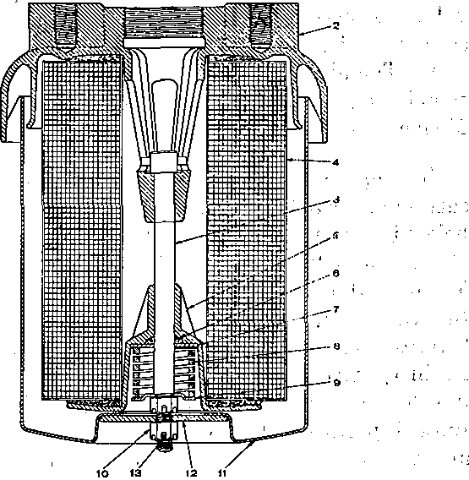
Fig. 6. Sectional Assembly View of the Type "L" Air Filter

TYPE "L" AIR FILTER
The Type "L" Air Filter is of the "cartridge type" which permits removal of the filter unit without the necessity of dismounting or disconnecting from the air compressor. Fig. 7, illustrates the filter unit and the exterior of the air filter, while Fig. 6 is a sectional assembly view showing the construction.
The inlet opening is formed in the under side of the cover 2 as an annular ring around the casing 11. As the air enters this opening, it passes upward and inward to the inside of the casing where it strikes a baffle and is directed downward before passing through the filter unit into the discharge opening. Some of the heavier particles of dirt are carried downward and deposited at the bottom of the casing cavity.
The cover is centrally threaded for the pipe connection to the air compressor, and is also provided with two mounting lugs tapped for inch studs for mounting purposes. The casing is of pressed steel and is attached to the cover by means of tie bolt 3, washer 12 and nut 10. The casing houses the filter unit and acts as a dirt chamber. In the bottom are several small holes to permit drainage of moisture from this chamber. To dismantle the air filter for cleaning or replacing the filter unit, it is necessary to remove the cotter and nut from the end of the tie bolt to release the casing, and then a second cotter and nut from the tie bolt to release the spring retainer assembly and the filter unit.
The filter unit comprises a corrugated and radial wire mesh assembly, covered with a layer of thick felt so constructed that the actual filtration area is many times the inlet or outlet passage areas. This unit is also provided

with large felt washers on each end to seal on shoulders surrounding the outlet passage on the upper end and with the spring cage on the lower end.
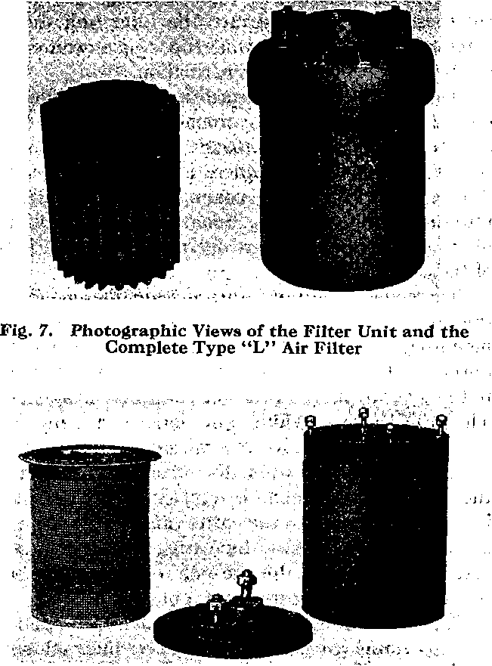
Fig. 8. Disassembled View of the No. 54 Air Strainer

. No. 54 AIR STRAINER
As will be seen from the illustrations, this is a very large double cylindrical strainer (overall dimensions approximately 10 "xl4") with an inner strainer of perforated sheet steel, galvanized, and an outer strainer of coarse galvanized wire mesh, the intervening space being well packed with curled hair. A galvanized iron shell encircles the strainer proper, preventing dirt, oil and water from striking directly against the strainer and thereby reducing the possibility of trouble from clogging. The strainer may be quickly and conveniently taken apart, without disturbing any pipe connections, by removing the nuts from the four studs.
Fig. 9. Sectional View of the No. 54 Air Strainer
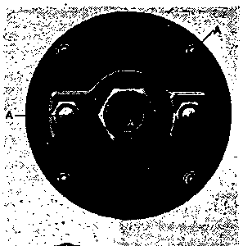

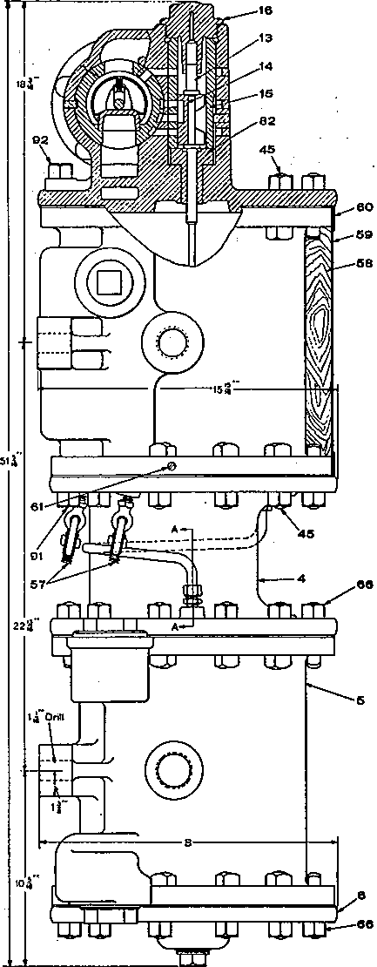
Fig. 10. 11" Air Compressor outline view with section through the Reversing Valve

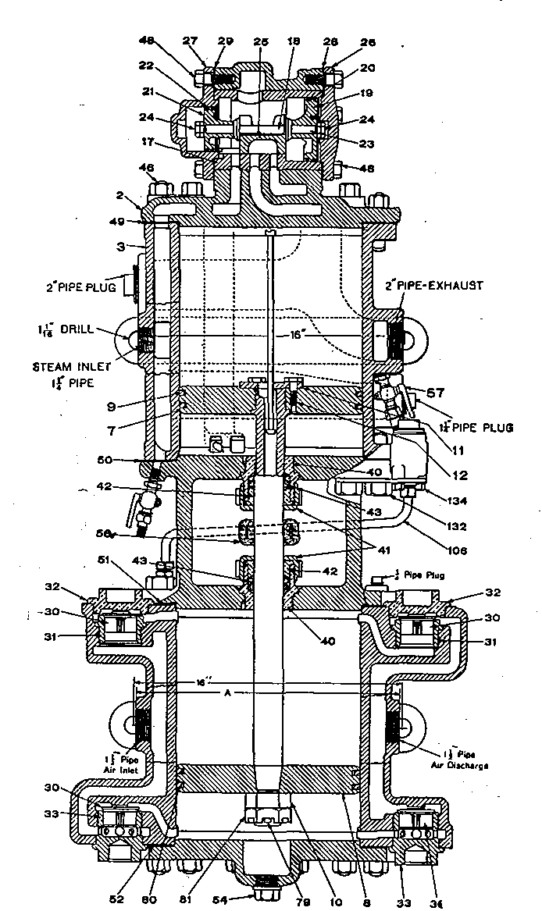
Fig. 11. 11' Air Compressor sectional Assembly View

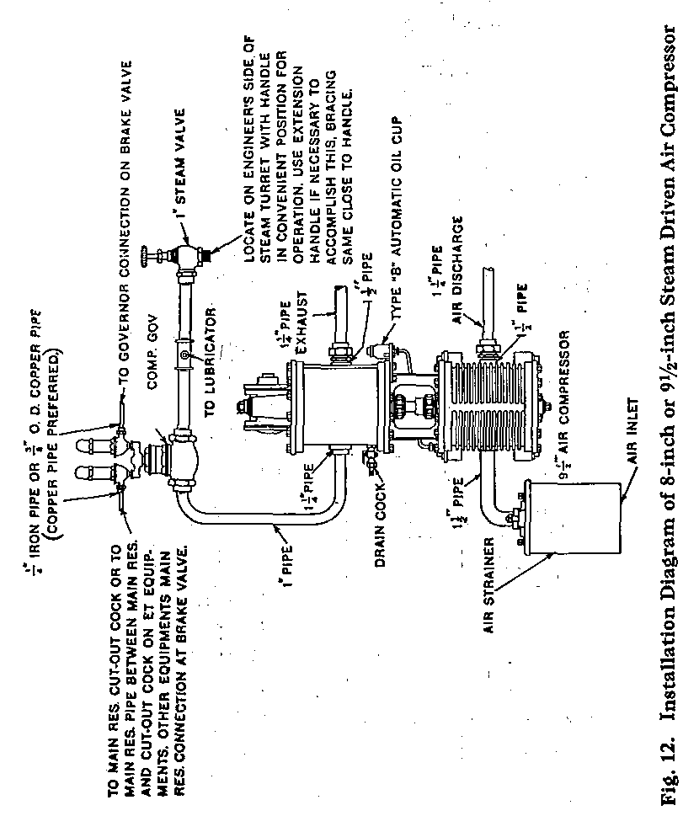

INSTALLATION AND OPERATING INSTRUCTIONS
Piping. All pipes should be hammered to loosen the scale and dirt, have burrs removed, and be thoroughly blown out with steam before erecting; bends should be used wherever possible instead of ells, and all sags avoided. A suitable compound to make a tight joint should be i applied on the male' threaded portion only, and never in the socket. Do not use red or white lead.
The steam valve should be located in the cab on the engineman's side of the steam turret with the handle in a convenient position for operation.
The steam cylinder lubricator connection is taken off from the pipe between the steam valve and governor.
A compressor governor is placed in the steam supply pipe between the lubricator and the compressor, its function being to start and stop the compressor automatically within predetermined pressure limits.
Figs. 12 to 15 inclusive, 17 and 18, show the recommended arrangement and sizes of the piping for one compressor and also for two compressor installations. The size of pipe, particularly of the steam supply pipe, should never be smaller than that indicated in order to obtain maximum efficiency from the compressor.

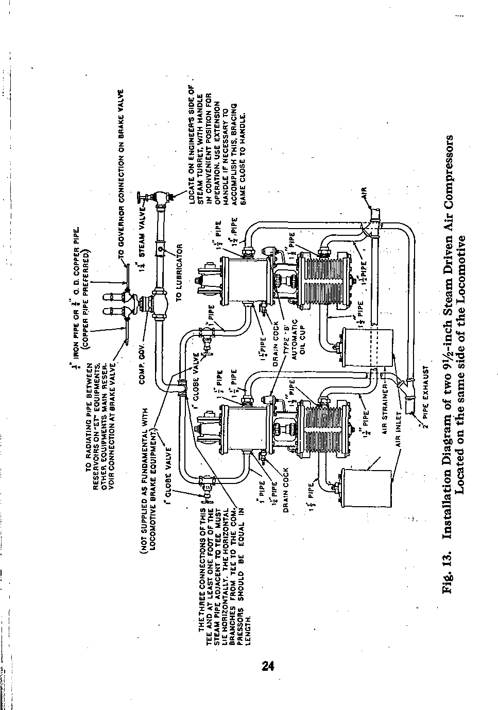

Starting and Running. The drain cocks (Figs. 2 and 3) are placed at the lowest points of the steam passages a and b², as shown, for the purpose of draining water from steam condensed after the compressor stops. They should always be left open when the compressor stands idle for any length of time. These drain cocks are provided with suitable union fittings so that drain pipes may be connected to them if desired.
In starting a compressor, always run it slowly until it becomes warm, permitting the condensed steam to escape through the drain cocks and the exhaust, until there is sufficient pressure in the main reservoir (25 to 30 pounds) to provide an air cushion. Then close drain cocks and open the steam (throttle) valve sufficiently to run the compressor at the normal speed. Never run the compressor faster than is necessary to do the work required. Racing or running at excessive speeds should not be allowed. The compressor governor automatically controls the starting and stopping of the compressor.
To Stop the Compressor. (1) Close the feed and steam valves on the sight-feed lubricator, if the compressor. has a separate one, or the feed, if supplied from the locomotive lubricator; (2) then close the steam (throttle) valve; (3) and open all drain cocks on the compressor. Keep the steam valve closed and the drain cocks open when the compressor is not working. The main reservoir drain cocks should also be left open when the compressor is stopped for any length of time. The compressor should always be stopped while the engine is over the ash pit. If permitted to run, ashes and dust

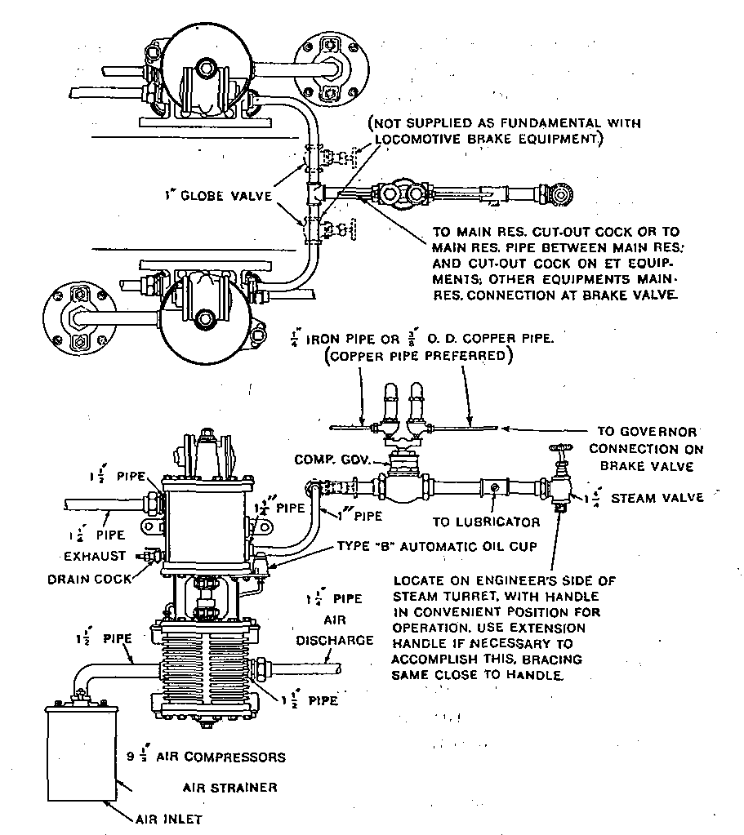
Fig. 14. Installation Diagram of two 9 1/2-inch Steam Driven Air Compressors located on opposite sides of the Locomotive

will be drawn into the air cylinder and injure it, besides clogging up the air strainer.
Lubrication—Air Cylinders. On account of the high temperatures developed by air compression, the variation between maximum and minimum delivered air pressures, and the necessity of preventing oil from passing into the system, one of the vital problems in efficient compressor operation is to provide a simple means for supplying lubrication to the air cylinders in proper quantity and at regular intervals. Non-automatic methods may be employed and satisfactory results obtained as long as care and attention are exercised to provide just enough lubrication to keep the compressor in a properly lubricated condition, but experience has shown that this is very difficult to obtain. The ideal method is obviously that which involves feeding the proper amount of lubricating oil to the air cylinders during each cycle of the pistons and causing this feeding of oil to cease when the compressor stops operating. These "automatic" requirements are fully satisfied by the Type B Automatic Air Cylinder Oil Cup, with which the only manual operation necessary is that of filling the cup with oil at the required intervals.
The construction and operation of the automatic oil cup are very simple, as will be evident from the sectional illustration, Fig. 16. There is an oil chamber a which is filled from the top when the cap nut 5 is removed. The cap nut is provided with a vent hole / so located that when the seal between the cap and body is broken the air pressure is vented to the atmosphere, thereby permitting

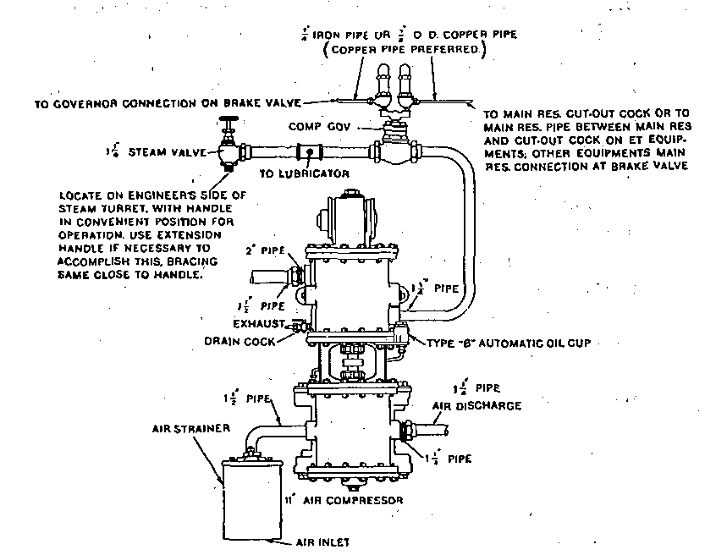
Fig. 15. Installation Diagram of 11-inch Steam Driven Air Compressor

the filling operation to be performed while the compressor is running. The stem portion 3 of the body 2 has a central passage b communicating at the bottom with the pipe connection leading to the air cylinder, and at the top with chamber a through the cavity in the cap nut. This passage has its top outlet on the side so as to permit chamber a to be filled without possibility of pouring oil. directly into the passage, which would defeat the very purpose of the lubricator.
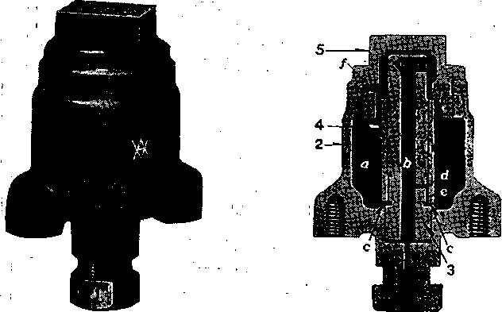
Fig. 16. Exterior and Sectional Views of the Type B-3 Automatic Oil Cup
An oil port d of definite size is located in the stem and connects passage b to an annular feeding cavity e which is formed by a recess in the stem and the neat fitting sleeve, around it. This sleeve has two diametrically placed notches c at its lower end, which connect chamber a with cavity e.

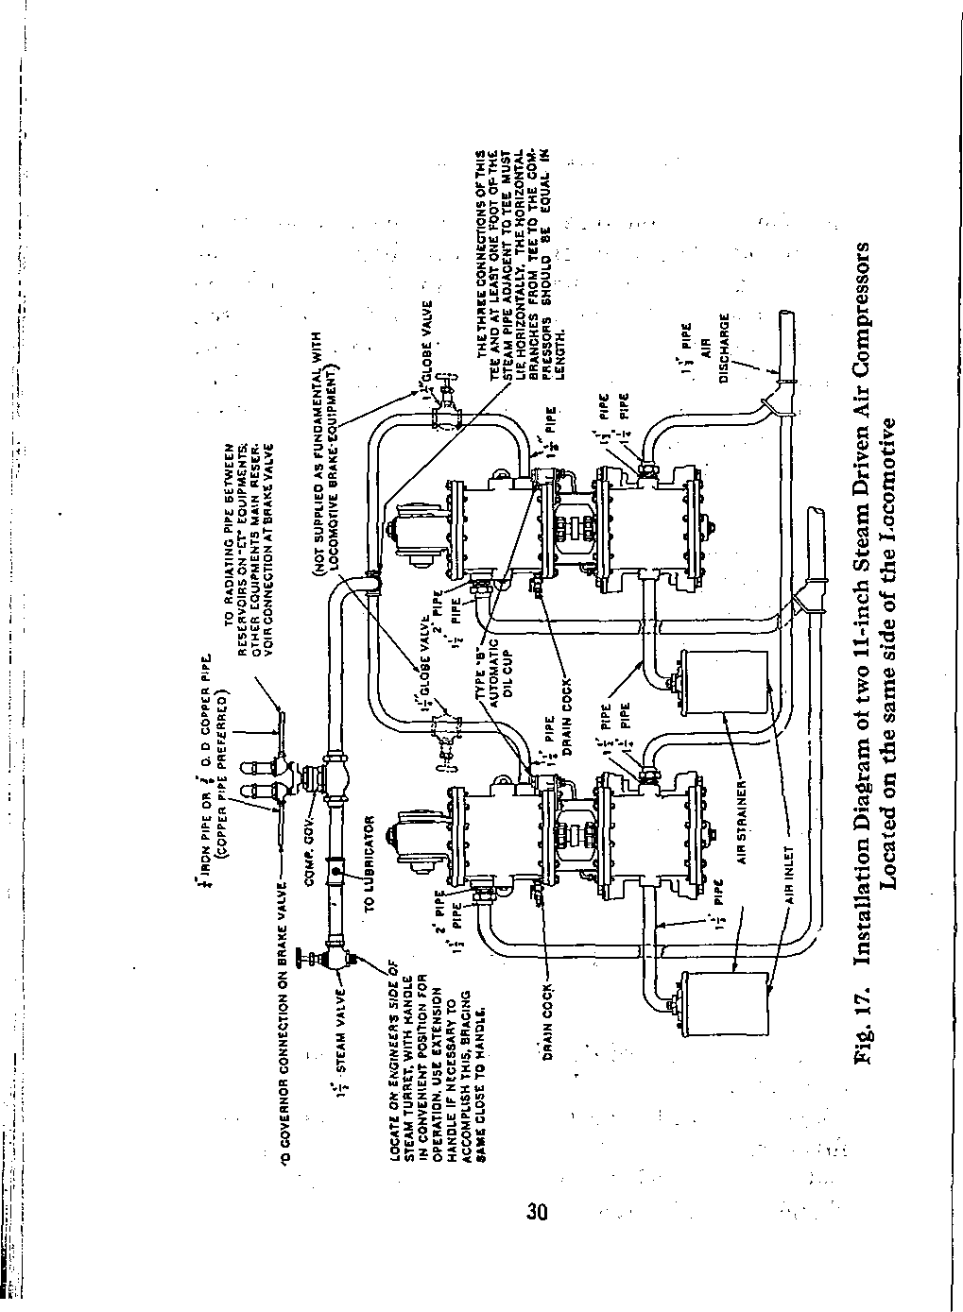

When the compressor makes its upward stroke, air is forced up through passage b and into the space above the oil in chamber a.
The lubricant in the cup will flow through the notches c into the space between the stem 3 and the sleeve 4 and rise in space e by capillary attraction and will then enter opening d to passage b, from which, on the downward stroke of the compressor, the lubricant is carried with the flow of the air from the chamber on top of the oil, through passage b into the compressor cylinder. This small amount of oil supplied regularly and reliably is ample to adequately lubricate the air cylinder.
Due to the ability of this type of lubricator to supply minute particles of oil in uniform quantities to the air cylinder of the compressor during each tycle of operation, one filling of its oil chamber will supply sufficient lubrication to the compressor air cylinder for the average trip of a locomotive.
A good grade of standard locomotive saturated steam valve oil only should be used in the air cylinders. Superheated oil is not recommended for air cylinder lubrication because it tends to restrict the air passages, causing the compressor to heat unduly and to wear faster than with the lighter valve oil recommended.

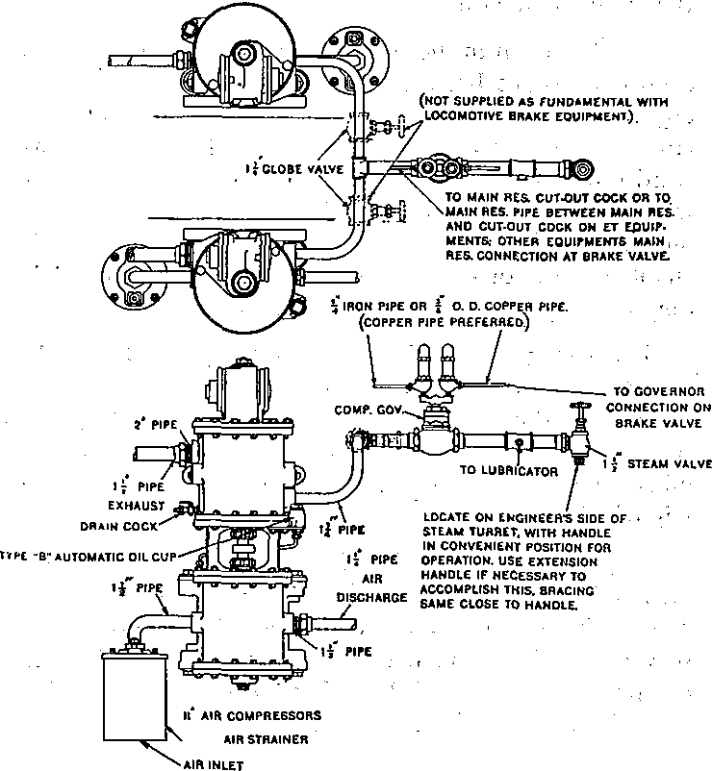
Pig. 18. Installation Diagram of two 11-inch Steam Driven Air Compressors Located on opposite sides of the Locomotive

Lubrication—Steam Cylinders. The steam cylinder lubricator (if used) should not be started until all condensation has escaped from the compressor and the drain cocks closed. After closing the drain cocks, start the lubricator to feed in ten or fifteen drops of oil as rapidly as possible, then regulate the feed to about two or four drops per minute for each compressor, No definite amount can be specified, as the amount of lubrication required depends on the work the compressor has to do, the quality of the steam, condition of compressor, and so on. Keep the lubricator feeding while the compressor is running.
A swab, well oiled, is essential on each piston rod.

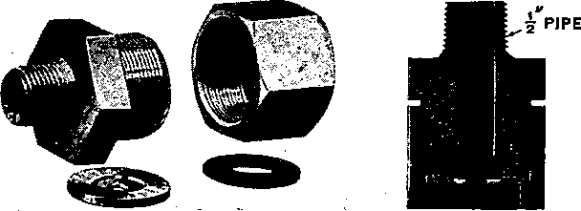
Fig. 19. Disassembled View and Sectional View of Disc Holder with Disc
Fig. 20. Showing Orifice Disc Holder and Gage attached to Main Reservoir Drain Cock

REPAIR SHOP AND ROAD TESTS
The Interstate Commerce Commission's "Rules and Instructions for Inspection and Testing of Steam Loco: motives and Tenders," dated 1919, specify as follows regarding steam compressor tests:
"The compressor or compressors shall be tested for capacity by orifice test as often as conditions may require, but not less frequently than once each three months." ;
The above Rules and Instructions also specify that the 9 1/2-inch compressor must make not more than 120 single strokes per minute in maintaining 60 lbs. main reservoir pressure against an 1/6 1/4-inch orifice; and that the 11-inch compressor must make not more than 100 single strokes per minute in maintaining 60 lbs. main reservoir pressure against a 3/16-inch orifice. For altitudes over 1000 feet the speed of the compressor may be increased five single strokes per minute for each 1000 feet increase in altitude.
We recommend the following method for making the above test:
Before making any test, the main reservoir should be drained and its connections should be tested for leakage as follows: After obtaining the main reservoir pressure corresponding to the governor setting, close the throttle to the compressor. Then close the main reservoir cutout cock when the standard SD (or SF) governor is used, if, however, the SG type of governor or the SF type with a manifold providing for a single main reservoir

connection to the governor is used, leave the main reservoir cock open and close the brake pipe cut-out cock tinder the brake valve and the cut-out cock in the supply pipe to the distributing valve and place the brake valve handle on lap. If no cut-out cock is used, as with the A-1 Equipment, place the brake valve handle on lap. Bleed down reservoir pressure to about 62 or 63 lbs. Allow the pressure to leak down to 60 pounds (that is, to settle down to an equalization of temperatures), and note the amount of drop from this pressure during one minute. This drop must not exceed 2 pounds. If a greater leakage than this exists, it must be reduced to this limit before proceeding with the compressor test, otherwise the test would indicate a poorer condition of the compressor than is the case, due to extra labor required to maintain this leakage.
After the main reservoir and its connections have been tested for leakage as above, the compressor should be tested as follows:
The orifice disc is placed in a special holder, Fig. 19, supplied for this purpose which should be connected by piping to the main reservoir drain cocks, as illustrated; a test gage should also be inserted between the drain cock and the disc holder, as show;n in Fig; 20. Then close the main reservoir cut-out cock,if the SD (or SF) governor is used; if, however, the SG type of governor or the SF type with a manifold providing for a single, main reservoir connection to the governor is used, leave the main reservoir cock open and close the brake pipe cut-out cock under the brake valve and the cut-out cock in the supply pipe to the distributing valve

and place the brake valve handle on lap. If no cut-out cock is used, as with the A-l equipment, place the brake valve handle on lap. Then start the compressor and raise the pressure in the main reservoirs to slightly below 60 lbs. Open the drain cock to the orifice and throttle the steam supply to the compressor until the main reservoir pressure is maintained at approximately 60 lbs. Then count the strokes of the compressor required to maintain this pressure during one minute. This number must not be in excess of 120 for the 9 1/2- inch compressor and 100 for the 11-inch compressor.
During the tests it should be assured that boiler pres- sure is at all times at least sufficient to obtain the required number of strokes against 60 lbs. air pressure when the throttle to the compressor is full open.

Test of Steam End
: While the Interstate Commerce Commission makes no mention of tests of the steam end, such test should be made to determine whether or not the efficiency of the steam end of the compressor is lower than warrants continuing it in service or after having been repaired and overhauled, it is in proper condition to be returned to service. ,
The test specifications given hereinafter are based upon the performance of a number of compressors in what may be termed good average conditions. It should be understood that the limits specified are neither those which should condemn a compressor nor necessarily the best performance which should be expected from a com-

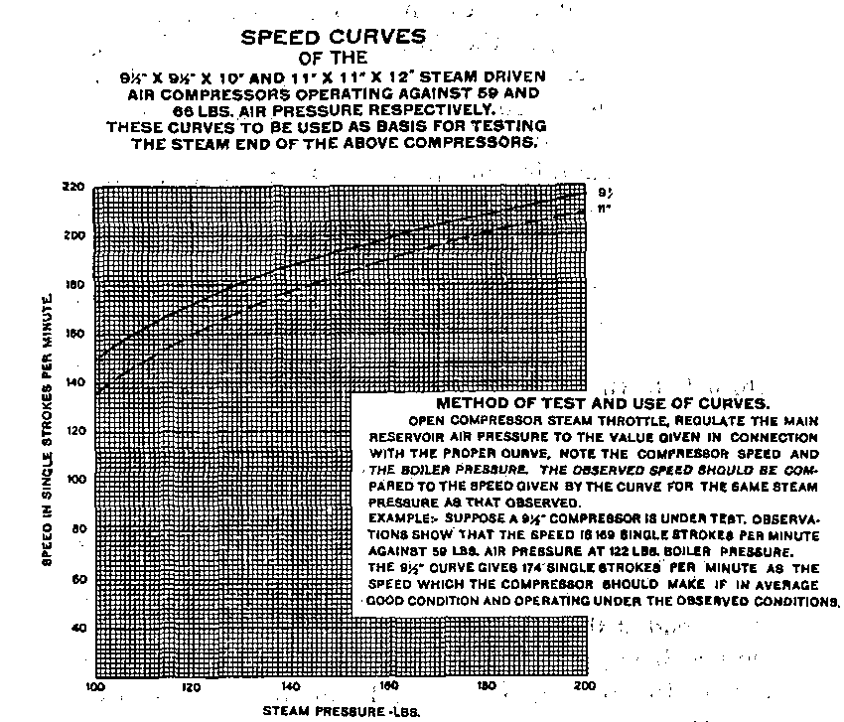
Curves of the 9 1/2-inch and 11-inch Compressors

pressor in-the best possible condition. The condemning limit should be established by those familiar with existing service requirements. The tests specified merely indicate the method which we would recommend.-
In establishing a minimum passable performance of the compressor, it should be borne in mind that this limit should not be set too low. This is to prevent the compressor getting into such poor condition as to require expensive repairs. For this reason we'strongly recommend that the condemning limit should never be established below 75 per cent for the steam end of the tests specified hereinafter, no matter what the service may be or the apparent ability of the compressor to meet operating requirements, even with a considerably lower efficiency than this. Where operating conditions demand a more rigid requirement, the condemning limit should be raised to an amount determined by the judgment of those in charge.
The steam end of the compressor should be tested in the following manner:
The compressor steam throttle .should be opened wide and the main reservoir pressure should be regulated by means of a cock or valve leading to the atmosphere until the pressure in the reservoir reaches 59 lbs. in the case of the 9 1/2-inch compressor or 66 lbs. in the case of the 11-inch compressor. When this pressure has been obtained, the locomotive boiler pressure and the compressor speed in single strokes per minute should be observed and compared with that shown on the curve

which represents what the performance, ought to be if its steam end is in good average condition.
For example, suppose with the steam throttle opened wide and the main reservoir pressure maintained at 59 lbs. with the 9 1/2-inch compressor by bleeding it to the atmosphere at a given rate, observations show that a speed of 169 single strokes per minute is attained with a boiler pressure of 122 lbs. The curve shows that with a boiler pressure of 122 lbs. and operating against 59 lbs. main reservoir pressure, the compressor speed should be 174 single strokes per minute if the steam end of the compressor is in good average condition. If the observed speed is less than that indicated on the curve for the given conditions, the judgment of those in charge should determine whether the compressor be overhauled.
If the condemning limit for the steam end has been set at 75 per cent of the performance of a compressor in good average condition, the speed of the compressor should be not less than 75 per cent of the speed called for by the curve at a point corresponding to the particular condition of steam pressure under which the compressor was tested. For instance, in the case under consideration, the compressor should have a speed of not less than 75 per cent of 174 strokes, or 131 single strokes per minute.

DISORDERS—Causes and Remedies
Compressor Refuses to Start. Cause: — insufficient oil, due to failure of lubricator to feed properly, or oil washed out of the cylinder by water of condensation ; leaky piston rings in the small end of the main valve piston; or rust having accumulated during time compressor has lain idle. Remedy:—shut off steam, take off reversing valve cap, pour in a small quantity of valve oil, replace cap, and then turn on steam quickly. In many cases when the compressor will not start when steam is first turned on, if steam is then turned off and allowed to remain off one or two minutes, and then turned on quickly, it will start without the use of any oil, except that from the lubricator.
Compressor Groans; Cause :—(1) air cylinder needs oil. Remedy:—(1) put some valve oil in air cylinder. Cause:—(2) piston rod packing dry and binding. Remedy: -— (2) saturate piston swab with valve oil. Cause:—(3) , steam cylinder needs oil. Remedy:—(3) increase lubricator feed.
Excessive leakage past-the air piston packing rings or past a discharge valve causes heating, destroys lubrication, and results in groaning.
Uneven Strokes of the Compressor; Cause: probably (1) sticky air valves; (2) improper lift of air valves; (3) clogged discharge valve passages; (4) leaky air valves; or (5) binding or cutting of the reversing rod. Remedy:— locate cause, if possible, and correct it by cleaning out clogged or dirty passages and air valves, replacing worn or leaky valves or straightening or replacing the reverse rod.

Slow in Compressing Air. Cause: — (1) leakage past the air piston packing rings, due to poor fit, or wear in cylinder or rings; (2) valves and passages dirty; or, (3) air suction strainer clogged. Remedy:—(1) and (2). To determine which is causing the trouble, obtain about 90 lbs. air pressure, reduce the speed to 40 or- 60 single strokes per minute, then listen at the "Air Inlet" and note if air is drawn in during only a portion of each stroke, and if any blows back. If the latter, an inlet valve is leaking. If the suction does not continue until each stroke is nearly completed, then there is leakage past the air piston packing rings or back from the main reservoir past the air discharge valves. Remedy:—(3) clean strainer thoroughly.
Compressor Erratic in Action. Cause: — worn condition of valve motion. Remedy:—replace it.
Compressor Heats. Cause:—(1) air passages are clogged; (2) leakage past air piston packing rings; or, (3) the discharge valves have insufficient lift. Remedy: —(1) clean air passages; (2) renew air piston rings; (3) regulate lift of discharge valves to of an inch. A compressor in perfect condition will become excessively hot and is liable to be damaged if run very fast and continuously, for a long time.
Compressor Pounds. Cause — (1) air piston is loose; (2) compressor not well secured to boiler, or causes some adjacent pipe to vibrate; (3) the reversing plate, 69, is loose; or, (4) the reversing rod or plate may be so worn that the motion of compressor is not reversed at the proper time. Remedy:-—repair and renew worn parts and tighten loose connections.

MAINTENANCE
In connection with the problem of good maintenance for steam driven air compressors of this type, the heating of the air cylinder incident to air compression is perhaps the most important. The operation of the compressor continuously at high speeds or against excessive pressures inevitably results in high temperatures which tend to destroy the lubrication" causing the air cylinders to cut, and the groaning of the air compressor, besides filling the discharge passages with deposits from burnt oil, producing undesirable condensation of moisture in the brake system, and in general, reducing the overall efficiency of the compressor.
Under normal conditions, the speed should not exceed 140 strokes per minute and such a speed should not be maintained continuously for any considerable time, as even tfris speed will eventually cause excessive heating. Continuous running at high speed will cause excessive heating of the air end of the compressor. Overheating from this cause is an indication that a compressor of larger capacity is required.
It is therefore desirable, first, that the compressor be of ample capacity for the service desired; second, that it be well lubricated and otherwise maintained in good condition; and third, that leakage from any source whether within the air compressor itself or in the brake system be minimized in every practical way.

One of the most serious leaks is through the air cylinder stuffing box, as it not only greatly decreases the air delivered and, by the faster speed required increases the heating, but it also causes pounding through loss of cushion. When tightening the packing, do not bind the rod, as to do so will damage both the packing and the rod. Be careful not to cross the gland nut threads.
With two compressors per engine, the separate throttles should be kept wide open and the speed regulated by the main compressor throttle. The purpose is to equally divide the work.
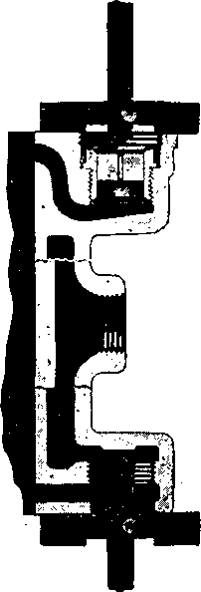
Fig. 21. Method of Adjusting Gage to Determine the Lift of both Upper and Lower Air Valves

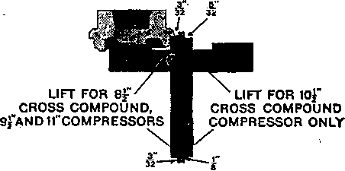
Fig. 22. Application of Gage to Valve Cap to determine Lift of Upper Air Valve
If necessary to replace a broken air valve on the road or elsewhere not permitting of proper fitting, at the earliest opportunity have the repairman replace the temporary valve with another so as to insure the correct angle and width of valve and seat contact, the needed ground joint and the requisite lift of of an inch for all valves. When the combined wear of the valve and seat increases the lift more than ^ of an inch above standard, the seat is liable to be injured and the valve broken, with consequent annoyance and delay. For the purpose of readily determining when the point of maximum wear has been reached, and when the valves have the proper lift, when adjusting the lift, we furnish an Air Valve Lift Gage, as illustrated in Figs. 21, 22 and 23.
To determine the lift of the upper air valve, the gage is first applied to the top flange of the air cylinder, as illustrated in Fig. 21 and the sliding arm adjusted until its end rests against the top of the stop on the air valve, in which position it is locked by means of the thumb nut. With the arm thus locked; the gage is applied to the valve cap, as illustrated in Fig. 22, and if the valve has proper lift, the under side of the collar of the valve cap will

just rest upon the shoulder of the sliding arm, as illustrated. If the gage arm fails to touch the stop on the valve when the shoulder on the sliding bar rests upon the face of the collar, the valve has a lift greater than standard by an amount equal to the distance between the gage arm and the stop. If this lift is greater than the maximum permissible, a repair valve having a long stop is substituted for the old valve and the stop lowered until the standard lift is reached, as indicated by the gage.
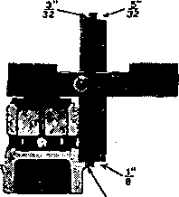
Fig. 23. Application of Lift Gage to Lower Air Valve and Cage
To determine the lift of the lower air valve, the gage is first applied to the bottom flange of the air cylinder as illustrated in Fig. 21, and the sliding arm adjusted until its end rests against the stop on the cylinder, in which position it is locked by means of the thumb nut. With the arm thus locked, the gage is applied to the air valve cage and air valve, as illustrated in Fig. 23, and if the valve has proper lift, the shoulder on the sliding arm will just rest upon the upper side of the collar of the air valve cage, as illustrated. If the gage arm fails to touch the stop on the valve when the shoulder on the sliding bar

rests on the collar face on the cage, the valve has a lift greater than standard by an amount equal to the distance between the stop and the gage arm.
In case the cylinders have been counter-bored at the entrance for the valve cage and valve and valve.chamber cap in such a way as to interfere with the application of the gage, as above described, it will be found necessary, in order to use the gage properly, to file away a small portion of the ridge so that the cross-bar of the gage will rest on the refaced surface of the valve chamber. In doing this, care should be taken to avoid injury to the refaced surface.
Never remove or replace the upper steam cylinder head with the reversing valve rod in place, as to do so will almost invariably result in bending the rod. A bent rod is very liable to cause a "pump failure."
To remove or replace the reversing valve and rod, steam and air pistons should be stopped at about half stroke, either by the use of steam or by removing the cylinder head plug from the lower head and inserting a rod or bar. The reversing valve and rod should then be raised so that the button on the rod can be disengaged from the reversing valve plate through the offset hole, and so entirely removed.
It is evident that a compressor cannot compress more air than it draws in and not that much if there is any leakage to the atmosphere about the air cylinder. Bearing this in mind, practice frequently listening at the. "Air Inlet" when the compressor is working slowly while

being controlled by the governor, and wherever a poor suction is noted on either or both strokes locate and report the fault.
Any unusual click or pound should be reported, as it may indicate either a loose piston or a reversing valve plate cap screw or other serious fault.
Any steam leakage that can reach the Air Inlet of the compressor should be promptly repaired as such increases the danger of water entering the brake pipe.
Keeping the suction strainer clean is of the utmost importance, as even a slightly clogged strainer will greatly reduce the capacity where the speed is at all fast. A seriously or completely obstructed strainer, as by accumulated frost, aggravated by rising steam, will increase the compressor speed and will also be indicated by inability to raise or maintain the desired pressure.
It is an aid to good operation to thoroughly clean the air cylinder and its passages at least three or four times a year, by circulating through them a hot solution of lye or potash in the proportion of 4 ounces of potash to one gallon of water. This should always be followed by sufficient clean, hot water to thoroughly rinse out the cylinder and passages, after which a liberal supply of valve oil should be given the cylinder. Suitable tanks and connections for performing this operation can easily be arranged in portable form. Never put kerosene oil in the air cylinder to clean it.

CLEANING THE TYPE "L" AIR FILTER Method of Cleaning Air Filter Unit
At locomotive shopping periods, the filter unit should be removed for cleaning. If the dirt deposited on the convolutions of the strainer is dry, it may be dislodged by jarring the strainer on a hard surface and by the use of compressed air that is free from precipitated moisture. The blast of air should be directed along and not against the outside surface of the convolutions. If the dirt is oily, the strainer should be dipped in a cleaning fluid such as mineral spirits or a similar solvent, and then subjected to an air blast as previously described. If means are available to spray the fluid on the strainer, this system can be followed to advantage as it avoids excessive absorption of cleaning fluid.

Filter Body
The filter casing should be thoroughly cleaned. If any corrosion is noted, the casing should be wire brushed then dipped in Trichlorethylene or a suitable solvent cleaner. Following the cleaning, the casing should be heated to a temperature of approximately 200 degrees F., after which it should be immersed in NO-OXID at the same temperature. Remove and drain thoroughly, after which the filter can be re-assembled.

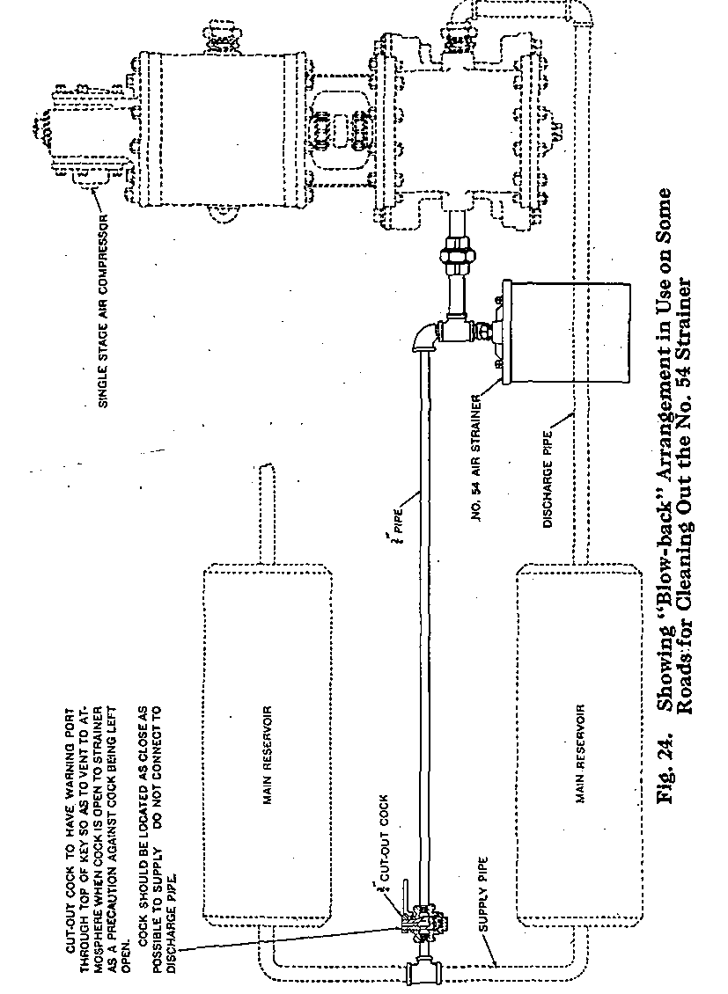
50

Blow-back Arrangement for No. 54 Air Strainer
In order to facilitate cleaning of the strainer between "shoppings" of the locomotive, some roads use a "blow- back" arrangement, as illustrated in Fig. 24. This consists of a 3/4-inch pipe connected to the main reservoir supply (but not to the discharge pipe); in which is placed a 3/4-inch cut-out cock having a warning port drilled from the outer end of the key into the cored passage so that a small amount of air will discharge when the cock is open and thereby help to guard against it being left open. The cock is placed near the point at which this connection to the main reservoir supply is made so as to reduce the liability of delay in case of pipe breakage beyond the cock. A tee is substituted for the ell at the strainer, and the blow-back pipe is connected through an ell to the tee opening which points vertically upward so that the blast of air will be downward into the strainer. To use the blow-back merely requires opening the inch cock for a few seconds at any time when main reservoir pressure is at maximum and the compressor is shut off.



